Community Champion Communications Toolkit

Theme: Supporting moms, dads, and grads

Suggested timeframe: May, June
Instructions for toolkits can be found here. Please adapt any/some/all of the below as you wish!
It’s that time of year again, Mother’s Day, Father’s Day, and graduations are key events that are just around the corner and can be perfect hooks to encourage talking about what matters most. We want to support you and help you support others in talking about health care proxies and preferences and recognize that sometimes these conversations may be difficult to have with the most important people in your life. Over these next two months, we aim to help you, or others think about how to bring this up with mother/father/mother or father figures, and what to bring up with young adults in your life who are graduating and/or “leaving the nest”, whether that’s your own kids, nieces, nephews, or your friends’ kids!
Remember, the best way to help someone start may be sharing that you’ve thought about this for yourself.
Sample messaging to be adapted and used in newsletters, email, flyers or other mass send outs
*yellow highlights below designate interchangeable text, depending on if you use for Mother’s or Father’s Day
Supporting graduates to pick their person and talk about preferences
Graduation season is just around the corner. It’s a perfect time to start conversations – with the young adults in your life (or maybe it’s you) – about what matters most and their preferences for health care before they “fly the nest”. Not everyone knows that once someone turns 18, their legal guardian (e.g., mother, father, grandparent, or other adult) isn’t necessarily their automatic decision maker should an accident happen, and they can’t speak for themselves. Have they thought about who they would choose to be their health care proxy? Are they resistant to having these conversations? A good first step is to introduce the idea of a health care proxy as something good for anyone to have in case of an emergency.
And, The Conversation Project (TCP) has you covered with free resources to help guide this conversation on their Get Started page. Check out their guides on Choosing a Health Care Proxy or Being a Health Care Proxy, and this lighthearted video about choosing a proxy among many others.
Supporting Moms [Dads]
This month, Mother’s Day [or Father’s Day] may be the perfect time to start or continue conversations about what matters most to a mother figure in your life, when it comes to life and health care wishes. Or perhaps you are a mother or mother figure [or father or father figure] and are looking for ways to approach this topic with your children/those you care for. If they are looking for gift ideas, let them know this conversation would be the perfect one!
Whether you are getting ready to tell someone what you value most or want to help someone else get ready to share their wishes with you, The Conversation Project has you covered with free resources to help guide this conversation on their Get Started page. Check out their Conversation Starter Guide, and this lighthearted but poignant video to help jumpstart a conversation, among many others.
And, sometimes, the best way to start is through story sharing. Check out and share 15 Moving Stories for Mother’s Day and Always [or 7 Stories from the Heart to Inspire You this Father’s Day] with your important people to jump start a conversation.

Sample text/images to adapt as you wish: for Social Media Posts or For Use in Newsletters, Flyers, Emails, etc. (instructions for use here, including downloading images)

The following examples are tailored to three social media platforms (Instagram, Facebook, X/Twitter) but can be used/adapted more broadly in other social media platforms and/or other communications methods you use.
Instagram:
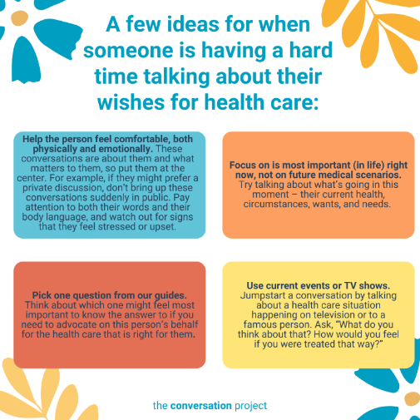
Option #1
This Mother’s Day [or Father’s Day], consider a conversation about what matters most to them. Talking to our mother [or father] about wishes for health care may not be easy. What if they won't want to have these conversations or they are having a hard time getting started?
We want to remind you that this is okay. Don’t force or pressure someone into talking about what matters to them. There are ways to do this informally that might feel more comfortable. Sometimes the idea of one big conversation is overwhelming — instead, you can have a bunch of short conversations. Pay attention to your tone – this is a time to be gentle, curious, and humble.
🔗 Go visit the link in our bio/visit the linktree in our bio to read @convoproject’s blog, 11 ideas for when someone is having a hard time talking about their wishes for health care.

Link to add to your bio/linktree: https://theconversationproject.org/tcp-blog/11-ideas-for-when-someone-is-having-a-hard-time-talking-about-their-wishes-for-health-care/
Additional hashtags to copy and paste into your first Instagram comment:
#TCP #TheConversationProject #StartingConversations #whatmattersmost #healthcare #healthcarewishes #ConversationStarter #familiesfacingcancer #whattosay #SeriousIllness #WhatMatterstoMe #WhatMattersMost #ConversationGuide #StartingTheConversation #medicaltreatment #healthcarewishes #HealthCareProxy #Aging #Retirement #MothersDay #AgeinPeace #FathersDay #LivingWill
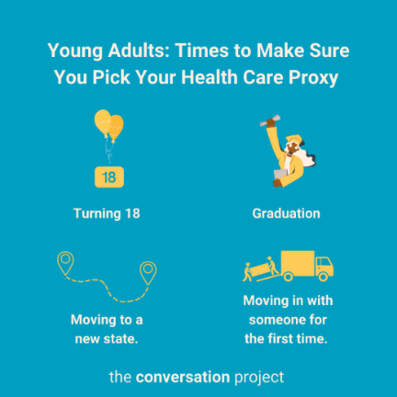
Option #2
It's graduation time and for anyone over 18 or soon-to-be flying from the nest, now is the time to make sure they have a designated decision maker if an accident happens, and they can't speak up for themselves.
🔗 Go visit the link in our bio/visit the linktree in our bio to read a few suggestions from @convoproject in their Guides for Choosing or Being a Proxy.

Link to add to your bio/linktree: https://theconversationproject.org/wp-content/uploads/2020/12/ChooseAProxyGuide.pdf
Additional hashtags to copy and paste into your first Instagram comment:
#TCP #TheConversationProject #PlanningAhead #FreeGuides #HealthCareProxy #Beingaproxy #supportinggraduates #graduationseason #graduates #2023graduates #collegegrads #conversation #caregiver #caregiving #healthcareagent #surrogate #healthcaresurrogate #powerofattorney #patientsafety #youngadults #foradults #youngadultministry #youngadult #adult

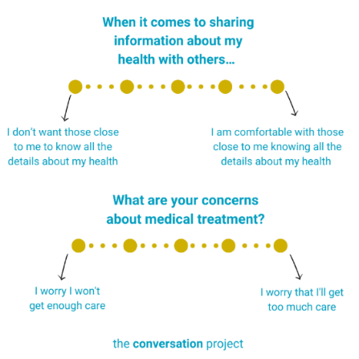
Option #3
This Mother’s Day [or Father’s Day] think about sharing what’s important to you, in your life and in your health with those who matter most to you, those who may need to make decisions on your behalf if you are unable to do so. Whether it’s a mother figure [or father figure] in your life, do they know what you value most? Have you talked with them about what you may be concerned with when it comes to your health? Will they know what decisions to make or information to share with others?
🔗 Go visit the link in our bio/visit the linktree in our bio to review more from @convoproject in their Conversation Starter Guide to help you think about and talk about what matters to you.
Link to add to your bio/linktree: https://theconversationproject.org/wp-content/uploads/2020/12/ConversationStarterGuide.pdf
Additional hashtags to copy and paste into your first Instagram comment:
#TCP #TheConversationProject #ConversationStarters #MedicalCare #Caregiver #Caregiving #SeriousIllness #WhatMatterstoMe #WhatMattersMost #ConversationGuide #StartingTheConversation #medicaltreatment #healthcarewishes #HealthCareProxy #Aging #Retirement #MothersDay #AgeinPeace #FathersDay #LivingWill
Facebook:
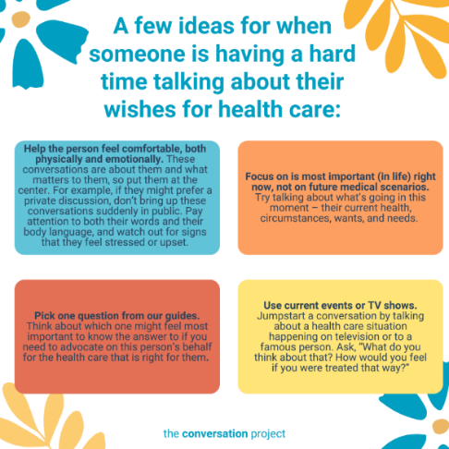
Option #1
This Mother’s Day [or Father’s Day], consider a conversation about what matters most to them. Talking to our mother [or father] about wishes for health care may not be easy. What if they won't want to have these conversations or they are having a hard time getting started?
We want to remind you that this is okay. Don’t force or pressure someone into talking about what matters to them. There are ways to do this informally that might feel more comfortable. Sometimes the idea of one big conversation is overwhelming — instead, you can have a bunch of short conversations. Pay attention to your tone – this is a time to be gentle, curious, and humble.
Read through @TheConversationProject’s blog, 11 ideas for when someone is having a hard time talking about their wishes for health care:
https://theconversationproject.org/tcp-blog/11-ideas-for-when-someone-is-having-a-hard-time-talking-about-their-wishes-for-health-care/
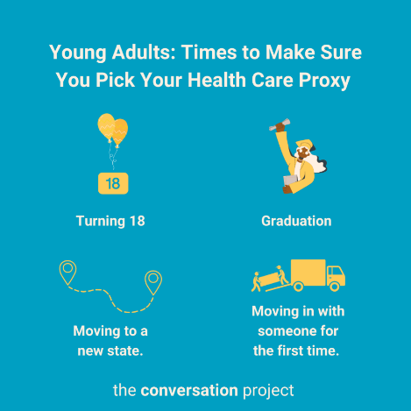
Option #2
It's graduation time and for anyone over 18 or soon-to-be flying from the nest, now is the time to make sure they have a designated decision maker if an accident happens, and they can't speak up for themselves.
Check out @TheConversationProject’s Guide for Choosing a Proxy: https://theconversationproject.org/wp-content/uploads/2020/12/ChooseAProxyGuide.pdf

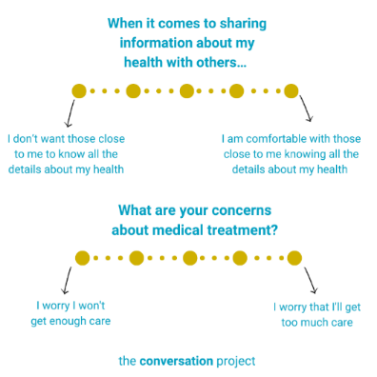
Option #3
This Mother’s Day [or Father’s Day] think about sharing what’s important to you, in your life and in your health with those who matter most to you, those who may need to make decisions on your behalf if you are unable to do so. Whether it’s a mother figure [or father figure] in your life, do they know what you value most? Have you talked with them about what you may be concerned with when it comes to your health? Will they know what decisions to make or information to share with others?
Read through @TheConversationProject’s Conversation Starter Guide to help you think about and talk about what matters to you: https://theconversationproject.org/wp-content/uploads/2020/12/ConversationStarterGuide.pdf

X/Twitter:
Additional hashtags (to consider based on post/character space):
#Supportingyoungadults #supportingparents #supportingcollegegraduates #graduating #graduation #highschool #seniors #student #highschoolgraduation #supportingmoms #supportingdads #graduate #MothersDay #FathersDay
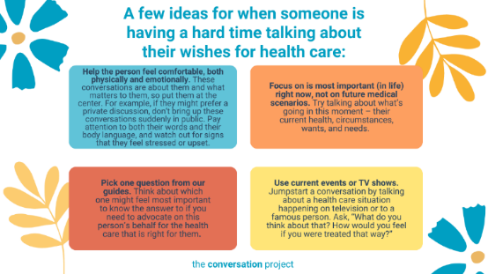
Option #1
This Mother’s Day [or Father’s Day], consider a conversation about what matters most to them. Sometimes the idea of one big conversation is overwhelming — instead, you can have a bunch of short conversations.
Read @convoproject's blog for more: https://theconversationproject.org/tcp-blog/11-ideas-for-when-someone-is-having-a-hard-time-talking-about-their-wishes-for-health-care/
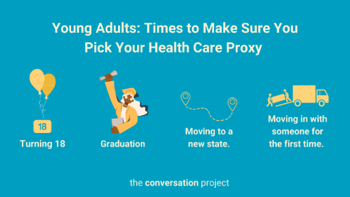
Option #2
It's graduation time and for anyone over 18 or soon-to-be flying from the nest, now is the time to make sure they have a designated decision maker if an accident happens, and they can't speak up for themselves.
@convoproject's guide for Choosing a proxy:
https://theconversationproject.org/wp-content/uploads/2020/12/ChooseAProxyGuide.pdf

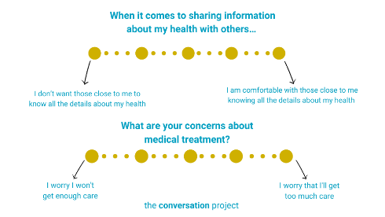
Option #3
Whether it’s a mother figure [or father figure] in your life, have you talked with them about what you may be concerned with when it comes to your health?
Read through @TheConversationProject’s Conversation Starter Guide this Mother's Day [or Father's Day]: https://theconversationproject.org/wp-content/uploads/2020/12/ConversationStarterGuide.pdf
Other messages/images to use across social media from the Serious Illness Messaging Toolkit*:
Talk to the people who matter most about the care you want.
The more you speak up, the better your health care can be.
Tell your doctors what matters most to you.
You can get the care that’s right for you.

*A toolkit created in partnership during a three-year grant generously funded by The John A. Hartford Foundation and Cambia Health Foundation. Whether you want to steal and use the above messages 'as-is', or edit them to fit your organization's needs, or use them as inspiration, these messages are meant for you to steal. The only ask is that you take the time to really understand how the five messaging principles, detailed in the toolkit, come into play (so that you don't add in words we intentionally left out!). For more on the messaging principles, free messages, images and text, click this link and download the toolkit.
Be sure to tag, follow, and reshare content from The Conversation Project’s Instagram, Facebook, and X/Twitter accounts if you are looking for more content outside of this toolkit to support the theme: “Moms, Dads, and Grads”. We’ll be posting this and more, all of which you are welcome to adapt to your own usage.
@convoproject | @TheConversationProject | @convoproject

What do you think of this Toolkit? Please help us and take 2 minutes to answer 3 questions in our brief survey here.

