Community Champion Communications Toolkit

Theme: Supporting Others (with an eye towards caregivers)

Suggested timeframe: September-October-November
Instructions for toolkits can be found here. Please adapt any/some/all of the below as you wish!
It’s back-to-school and/or back-to-work time for many families and individuals after a bit of a summer break. We invite you to get active in your community and help people think about ways they may support others to talk about what matters to them. This could take the form of encouraging conversations in social circles such as book clubs, neighborhood clubs, places of worship, in educational settings, at the workplace, or other wider community spaces. Whether it’s supporting family, friends or others in your community, we have the resources to help – especially important for caregivers or anyone who may be a caregiver in the future.
And, as a proud champion of The Conversation Project, we encourage YOU to “walk the talk” – by first thinking about this for yourself before you help support others. Then, identify those who you might want to support, including caregivers in your life or throughout your community.
November is National Veterans and Military Families Month, National Hospice and Palliative Care Month, and National Family Caregivers Month. Review this guest blog, Building Bridges of Understanding: Conversations Through the End of Life for Veterans, for tips for meaningful conversations to ensure that Veterans’ experiences and preferences are acknowledged and respected. Check out our blog, Recognize Caregivers as Star Players on the Team, for tips and stories to share for supporting caregivers. And, visit the Caregiver Action Network’s resource page to learn more about promoting this year’s theme #CaregiversConnect, find resources, social media toolkit, stories, ideas on how to support caregivers, and more.
Sample messaging to be adapted and used in newsletters, email, flyers or other mass send outs
Finding ways to support others in your circles
Do you have someone in your life you are caring for or will take care of in the future? Do you know what’s important to them when it comes to their life and their wishes for health care? Now’s a great time to find out. Maybe you’re already prepared, but perhaps you know a caregiver in your community who may not be. It’s a great time to help others jump start these important conversations. And, The Conversation Project has free conversation starter guides and resources to help make it easier.

How might you start? Share an article, video or one of the below blogs to kick start or continue a conversation:
  - Talking About our Future – and Our Future Healthcare
  - Caring for My Future Healthcare Today
  - Won’t You Have These Conversations With Me?
  - In Search of A Good Death
  - Hands of Love
Where might you start? Host a conversation with those in your book club, your faith community, or other neighborhood group. Or, bring these conversations to your campus or your workplace, among other places.

Who might you start with? Consider those caring for individuals with Alzheimer's/other dementias, or a child with a serious illness, or someone with a recent diagnosis. Share the below guides to help:
- For Caregivers of People with Alzheimer’s or Other Forms of Dementia
- For Caregivers of a Child with Serious Illness
- What Matters to Me Workbook

Sample text/images to adapt as you wish: for Social Media Posts or For Use in Newsletters, Flyers, Emails, etc.

The following examples and images are tailored to three social media platforms (Instagram, Facebook, X/Twitter) but can be used/adapted more broadly in other social media platforms and/or other communications methods you use. (see instructions for use here, including how to download images for correct format)
Instagram:
For options #1a and 1b, you can choose to post these as two separate posts, or as one carousel post.
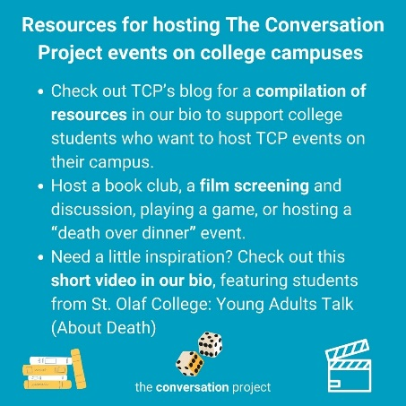
Option #1a
Are you a student and looking for ideas on how to jumpstart conversations with others on your campus?
Perhaps you are seeking additional training on how to jumpstart conversations with the individuals/families you’ll care for someday. No matter what you are studying and at which level (from undergraduate to doctorate), @convoproject has the resources to get you started to support others.
🔗 Go visit the link in our bio/visit the linktree in our bio to @convoproject‘s blog, "Resources for Students Interested in Conversations, Advance Care Planning and End of Life"
Links to add to your bio/linktree: https://theconversationproject.org/tcp-blog/resources-for-students-interested-in-conversations-advance-care-planning-and-end-of-life/ AND https://youtu.be/SgtECgQfzJ0?si=VFUuO4RFxrPm2-SO
Additional hashtags to copy and paste into your first Instagram comment:
#TCP #TheConversationProject #StoriesMatter #WhatMattersMost #Caregiver #SeriousIllness #healthcareproviders #dementia #endalz #dementiafriends #Caregiving #supportingothers #caregiversupport #studentresources #freeguides #ConversationStarter #eolplanning #eolcare #advancecareplanning #collegegrads #highschoolgrad #filmscreening #bookclub #letstalkaboutdeath #gamenight #deathoverdinner #collegecampus #eventplanning
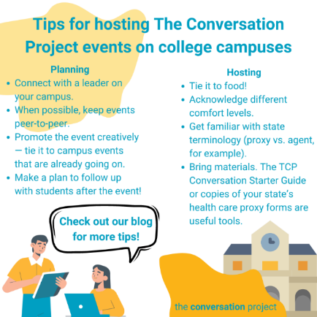
Option #1b
Want more tips on hosting events on your campus? Here are even more tips on planning, hosting, and following-up after.
What ideas have you brought back to your campus?
🔗 Go visit the link in our bio/visit the linktree in our bio to @convoproject’s blog for more resources on how to jumpstart conversations and support others.
Link to add to your bio/linktree: https://theconversationproject.org/tcp-blog/resources-for-students-interested-in-conversations-advance-care-planning-and-end-of-life/
Additional hashtags to copy and paste into your first Instagram comment:
#TCP #TheConversationProject #StoriesMatter #WhatMattersMost #Caregiver #SeriousIllness #healthcareproviders #dementia #endalz #dementiafriends #Caregiving #supportingothers #caregiversupport #studentresources #freeguides #ConversationStarter #eolplanning #eolcare #advancecareplanning #collegegrads #highschoolgrad #filmscreening #bookclub #letstalkaboutdeath #gamenight #deathoverdinner #collegecampus #eventplanning

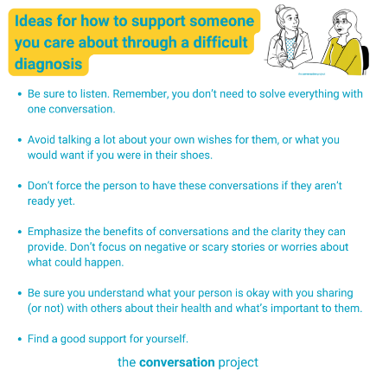
Option #2
If you’re looking for ways to support someone in your life who received a tough diagnosis, check out a recent blog post @convoproject wrote on this topic.

@convoproject has compiled conversation ice breakers, useful resources, and suggestions from people living with serious illness on how to be most helpful without overstepping boundaries.

We’d love to hear what else you’d add to the list. Comment below with additional suggestions.

🔗 Go visit the link in our bio/visit the linktree in our bio to A Guide to Supporting Others through a Difficult Diagnosis.
Link to add to your bio/linktree: https://theconversationproject.org/tcp-blog/a-guide-to-supporting-others-through-a-difficult-diagnosis/
Additional hashtags to copy and paste into your first Instagram comment:
#TCP #TheConversationProject #conversation #caregiver #caregiving #SeriousIllness #WhatMattersToMe #WhatMattersMost #Conversationguide #startingtheconversation #SuddenDiagnosis #Family #SeriousIllness #cancercare #cancercaregiver #talkingaboutcancer #parkinsons #alzheimers #Alzcaregivers #dementia #dementiacaregiver #als #alscaregivers #cysticfibrosis #HIV #palliative #palliativecare #caregiverlife #eldercare
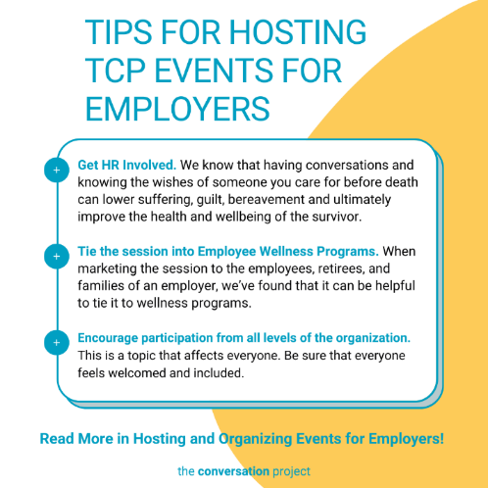
Option #3
We know that many employees are caregivers when they go home too.
Have you considered bringing advance care conversations to your workplace? Many groups are hosting conversation workshops for employees as part of wellness benefits, including employee resource programs among others. Tag a caregiver in your own work setting in the comments below.
🔗 Go visit the link in our bio/visit the linktree in our bio to read @convoproject's one-pager, Hosting and Organizing Events for Employers.
Link to add to your bio/linktree: https://theconversationproject.org/wp-content/uploads/2015/06/Hosting-and-Organizing-Events-for-Employers.pdf
Additional hashtags to copy and paste into your first Instagram comment:
#TCP #TheConversationProject #Conversation #Caregiver #Caregiving #SeriousIllness #WhatMatterstoMe #WhatMattersMost #ConversationGuide #StartingTheConversation #EmployeeCaregivers #EmployeeCaregiving #EventOrganization #SupportingCaregivers #SupportingOthers #SandwichGeneration #SandwichGenerationCaregivers #cancercare #talkingaboutcancer #chf #parkinsons #alzheimers #dementia #als #COPD #cysticfibrosis #awareness #dementiafriendly #endalzheimers #endalz #alzheimersdaughter #seriousillness #vasculardementia #lewybodydementia #lewybodycaregiver #youngcaregiver #dementiacaregiver #frontotemporaldementia #mixeddementia #TBI #CreutzfeldtJakobdisease #Huntingtonsdisease #parkinsonsdisease#braintumors#immunedisorders #nutritionaldeficiencies #Normalpressurehydrocephalus

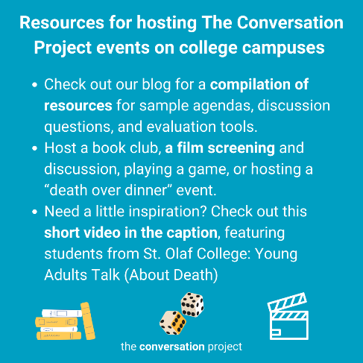
Facebook:
For options #1a and 1b, you can choose to post these as two separate posts, or as one carousel post.
Option #1a
Are you a student and looking for ideas on how to jumpstart conversations with others on your campus?
Perhaps you are seeking additional training on how to jumpstart conversations with the individuals/families you’ll care for someday. No matter what you are studying and at which level (from undergraduate to doctorate), @The Conversation Project has the resources to get you started on #supportingothers.
Check out @The Conversation Project’s blog for more tips on hosting events on campuses and more! https://rb.gy/cu8bl
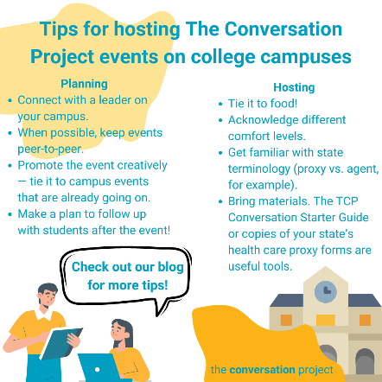
Option #1b
Want more tips on hosting events on your campus? Here are even more tips on planning, hosting, and following-up after.
What ideas have you brought back to your campus?
Check out @The Conversation Project’s blog for more resources on how to jumpstart conversations and support others: https://rb.gy/cu8bl

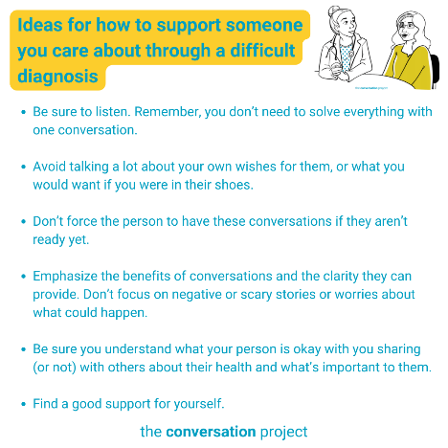
Option #2
If you’re looking for ways to support someone in your life who received a tough diagnosis, check out a recent blog post @The Conversation Project wrote on this topic. They’ve compiled conversation ice breakers, useful resources, and suggestions from people living with serious illness on how to be most helpful without overstepping boundaries.
We’d love to hear what else you’d add to the list. Comment below with additional suggestions and check out @The Conversation Project’s blog, A Guide to Supporting Others through a Difficult Diagnosis: https://bit.ly/36xof4z

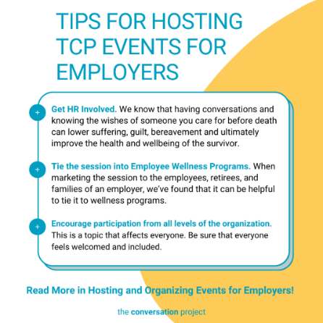
Option #3
We know that many employees are caregivers when they go home too. Have you considered bringing advance care conversations to your workplace? Many groups are hosting conversation workshops for employees as part of wellness benefits, including employee resource programs among others. Tag a caregiver in your own work setting in the comments below.
Check out @TheConversationProject’s one-pager with a few tips on Hosting and Organizing Events for Employers: https://theconversationproject.org/wp-content/uploads/2015/06/Hosting-and-Organizing-Events-for-Employers.pdf

X (Twitter):
Additional hashtags (to consider based on post/character space): #Support #AdvanceCarePlanning #WhatMatters #Caregiver #Caregivers
For options #1a and 1b, you can choose to post these as two separate posts, or as one carousel post.
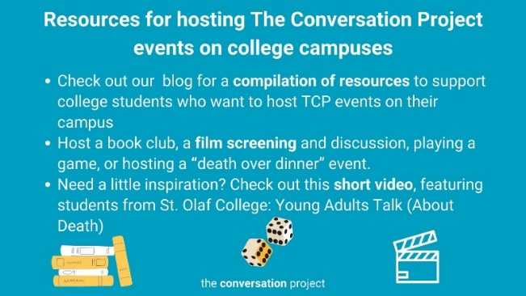
Option #1a
Are you a student and looking for ideas on how to jumpstart conversations with others on your campus? @convoproject has the resources to get you started to support others on their resource page: https://bit.ly/3zgpxtH
Link to short video: https://bit.ly/3LArgSd

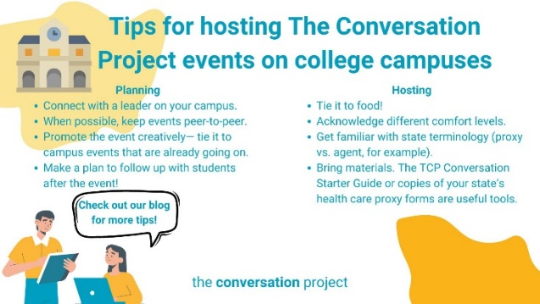
Option #1b
Want more tips on hosting events on your campus? Check out @convoproject’s blog for more resources on how to jumpstart conversations and support others: https://bit.ly/3zgpxtH

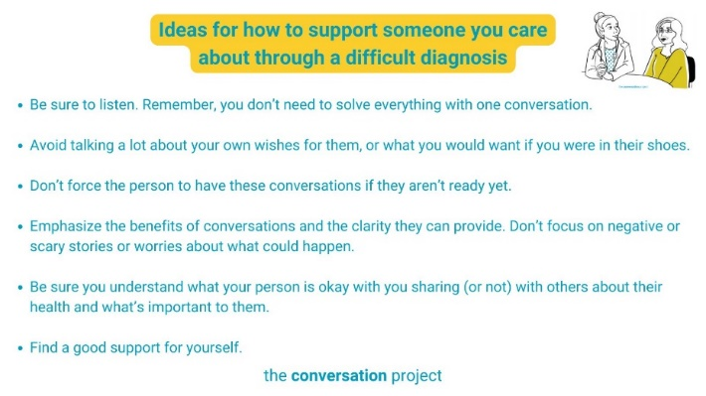
Option #2
If you’re looking for ways to support someone in your life who received a tough diagnosis, check out a recent blog post @convoproject wrote on this topic. We’d love to hear what else you’d add to this list: https://bit.ly/36xof4z

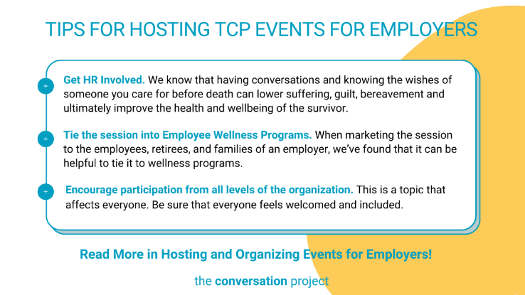
Option #3
We know many employees are caregivers when they go home too. Many groups are hosting conversation workshops for employees as part of wellness benefits, including employee resource programs among others. Check out @convoproject's resource here: https://bit.ly/45My3S7

Other messages/images to use across social media from the Serious Illness Messaging Toolkit*:

We’ll figure this out together.
Let’s make a plan for your care.

*A toolkit created in partnership during a three-year grant generously funded by The John A. Hartford Foundation and Cambia Health Foundation. For more free messages, images and text, click this link and download the toolkit.
Be sure to tag, follow, and reshare content from The Conversation Project’s Instagram, Facebook, and X/Twitter accounts if you are looking for more content outside of this toolkit to support the theme: “Supporting Others”. We’ll be posting this and more, all of which you are welcome to adapt to your own usage.
@convoproject | @TheConversationProject | @convoproject

Check out our community resource page for more free resources to share to support others!
What do you think of this Toolkit? Please help us and take 2 minutes to answer 3 questions in our brief survey here.

