Community Champion Communications Toolkit

Theme: Conversations on the Go – Summertime Travel

Suggested timeframe: July, August
Instructions for toolkits can be found here. Please adapt any/some/all of the below as you wish!
Summer is now in full swing – and a time when many of us/our community members head out on those summer road trips and planned family vacations. It may be a good time to start up or continue those conversations about what matters most when it comes to health care wishes. Over these next two months, we aim to help you and others in your community think about how to bring up these conversations on the go - with family, chosen family, friends, or those who matter most in our lives.
It’s also a good time to support any recent college or high school graduates about important decisions they may have to make regarding their health care in this new stage of their own life!
So, whether you’re looking for resources to help individuals choose their health care proxy or simply summer reading recommendations, keep an eye on the resources and tips we have to help you support these conversations on the go.
Sample messaging to be adapted and used in newsletters, email, flyers or other mass send outs
Summertime Travel: Conversations on the Go
Hitting the road this summer and taking a much-needed break? Looking for ways to start or continue those conversations about what matters most to you or those you care about when it comes to health care wishes? The Conversation Project (TCP) has you covered with free resources to help guide these conversations whether in a car, on a plane, or on a blanket soaking up the sun. For example, print ahead and bring Conversation Starter Guides with you. Pop on an audio version of their guides and listen together on your drive. Listen to a podcast on the plane, while sitting on the beach, or taking a walk at sunset. Or share this blog with friends or family for some beach reading and conversations.
Supporting Recent College/High School Graduates
It’s almost that time of year again (and maybe for some, it is that time already!), the people in your life who recently graduated school may be moving into a new place, a new city, and even starting new jobs or continuing their education journeys. In the mayhem of apartment hunting, finding furniture, curating a work or school wardrobe, and creating moving checklists, this can be an important time to spark conversations about what matters most to these young adults when it comes to health care wishes and who they may want to speak up for them in case of an emergency, if they are unable to do so.
Whether you want to help someone get ready to share their wishes with you, or you are getting ready to tell someone what you value most, The Conversation Project has you covered with free resources to help guide these conversations on their Get Started page. Check out their guides on Choosing a Health Care Proxy or Being a Health Care Proxy, or this lighthearted but poignant video to help jumpstart a conversation, among many others.

Sample text/images to adapt as you wish: for Social Media Posts or For Use in Newsletters, Flyers, Emails, etc. (instructions for use here, including downloading images)

The following examples are tailored to three social media platforms (Instagram, Facebook, X/Twitter) but can be used/adapted more broadly in other social media platforms and/or other communications methods you use.
Instagram:
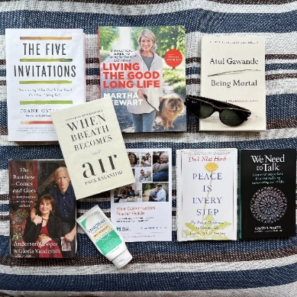
Option #1
Looking for something to add to your summer reading list this year? Here are a few of our favorites that we recommend, in addition to @convoproject’s suggestions in their 12 Additional Must-Read Books About Death and End-of-Life Care. Notice that we include the Conversation Starter Guide, wanting to inspire some conversations with the people who matter most to you.
Check out "The Rainbow Comes and Goes" by @Andersoncooper @gloriavanderbilt @harpercollins, "Being Mortal" by @atul.gawande @picadorbooks, "Peace is Every Step" by @thichnhathanh @randomhouse, "When Breath Becomes Air" by Paul Kalanithi @randomhouse, "The Five Invitations" by @fiveinvitations @flatiron_books, "Living the Good Long Life" by @marthastewart48 @MarthaStewart @clarksonpotter, and "We Need to Talk: Conversations to Ease Fear and Suffering Surrounding End of Life" by David White.
What would you add to this list? Tell us in the comments below.
🔗 Go visit the link in our bio/visit the linktree in our bio to read @convoproject’s blog, 12 Additional Must-Read Books About Death and End-of-Life Care.
Link to add to your bio/linktree: https://theconversationproject.org/tcp-blog/12-must-read-books-about-death-and-end-of-life-care/
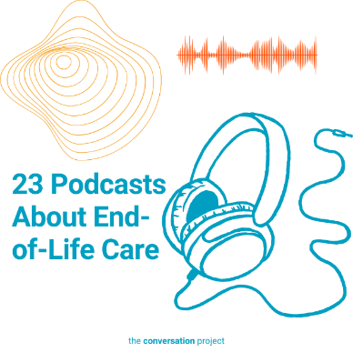
Additional hashtags to copy and paste into your first Instagram comment:
#TCP #TheConversationProject #StartingConversations #whatmattersmost #healthcare #healthcarewishes #ConversationStarter #atulgawande #andersoncooper #harpercollins #randomhouse #summerreadinglist #summerreading #beachreads #summerplans #grieftalk #beingmortal #livingthegood #marthastewart #booksaboutgrief #booksaboutdeath #talkingaboutdeath
Account tags to tag in post:
@Andersoncooper @gloriavanderbilt @harpercollins @atul.gawande @picadorbooks @thichnhathanh @randomhouse @fiveinvitations @flatiron_books @marthastewart48 @MarthaStewart @clarksonpotter
Option #2
Hitting the road this summer and taking a much-needed break? One of the best things you can do in the car, on the plane, or on a blanket soaking up the sun, is listen to a podcast – maybe even a podcast about care through the end of life. Listen to a podcast while sitting on the beach or taking a walk at sunset.
🔗 Go visit the link in our bio/visit the linktree in our bio to read a few suggestions from @convoproject in their blog, 23 Podcasts About End-of-Life Care.

Link to add to your bio/linktree: https://theconversationproject.org/tcp-blog/16-podcasts-about-end-of-life-care/
Additional hashtags to copy and paste into your first Instagram comment:
#TCP #TheConversationProject #EOLCare #EOL #Summertimetravel #SummerRoadTrips #Summertravel #beachpodcasts #TalkingAging #TalkingAboutDeath #SummerPlans #podcastlistening #AdvanceCarePlan #ACP #AdvanceCarePlanning #beachactivities #ApplePodcasts #Spotify #NPR #TalkingAging #Aging
#HealthCareProxy #Advocacy #AdvancedCare #WhatMattersMost
Account tags to tag in post:
@stitcherpodcasts @dyingkindness @sherylsmithrn @talking_aging @makespringhill @applepodcasts @onbeing @dreamnationlove @drreginakoepp @npr @tradeoffspod @endwellproject @bestlifebestdeath @theheartofhospice @thedeathdeck @libsyn @alica.forneret @985thesportshub

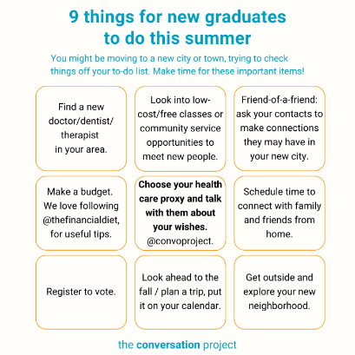
Option #3
📦 You may be planning to move this summer -- maybe to a new city and want some tips on handling a fresh start.
📝 If you've recently graduated from college/high school/ or took a job in a different place, you probably have a checklist (or multiple checklists) of things you have to do. Make time for these important items too! ✅
🗣️ And if you're over 18, one thing we can help you with is making sure you've chosen a health care proxy, and documented and talked about what your wishes are with the person you've chosen to speak for you in the event that you can't make your wishes heard yourself.
🔗 Link in bio to @convoproject’s guide to Choosing Your Health Care Proxy.
Link to add to your bio/linktree: https://theconversationproject.org/wp-content/uploads/2020/12/ChooseAProxyGuide.pdf
Additional hashtags to copy and paste into your first Instagram comment:
#TCP #TheConversationProject #ConversationStarters #ConversationIcebreakers #collegegraduates #collegegrads #highschoolgraduates #movingout #dormlife #newcity #meetingpeople #meetup #newgraduates #summerchecklist #summeractivities #healthcareproxy #advancecareplanning #chooseyourproxy #healthcarewishes #planatrip #summerroadtrip #vote #friendconnections #freeclasses #communityservice #getoutside
Facebook:
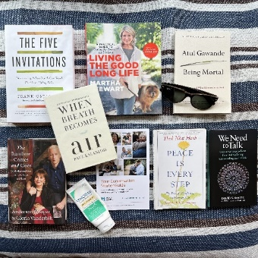
Option #1
🏖️ 📖 Looking for something to add to your summer reading list this year? Here are a few of our favorites that we recommend, in addition to @The Conversation Project’s suggestions in their 12 Additional Must-Read Books About Death and End-of-Life Care. Notice that we include the Conversation Starter Guide, wanting to inspire some conversations with the people who matter most to you.
Check out "The Rainbow Comes and Goes" by @Anderson Cooper and Gloria Vanderbilt, @HarperCollins, "Being Mortal" by @Atul Gawande, @Picador books, "Peace is Every Step" by @Thich Nhat Hanh, @Penguin Random House, "When Breath Becomes Air" by Paul Kalanithi (@Lucy Kalanithi MD), Penguin Random House, "The Five Invitations" Five Invitations by Frank Ostaseski @Flatiron Books, "Living the Good Long Life" by @Martha Stewart @Crown Publishing, and "We Need to Talk: Conversations to Ease Fear and Suffering Surrounding End of Life" by David White.
📚 What would you add to this list? Tell us in the comments below.
Read @The Conversation Project’s blog, 12 Additional Must-Read Books About Death and End-of-Life Care, here: https://bit.ly/3NahIjm
Option #2
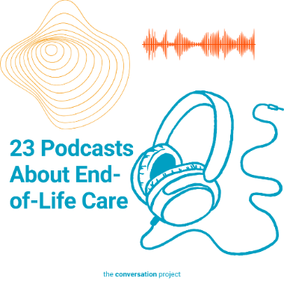
Hitting the road this summer and taking a much-needed break? One of the best things you can do in the car, on the plane, or on a blanket soaking up the sun, is listen to a podcast – maybe even a podcast about care through the end of life. Listen to a podcast while sitting on the beach or taking a walk at sunset.
Some featured podcast hosts and guests include: @Dr. Regina Koepp, @GeriPal, @Jewish Sacred Aging, @NPR, @libsyn - liberated syndication, @Sheryl Smith RN, @Coalition to Transform Advanced Care, @Dream Nation Love, @Alica Forneret, @The On Being Project, @98.5 The Sports Hub, @Stitcher, @The Hidden Brain, @Dying Kindness, @The Death Deck
Check out @The Conversation Project’s blog, 23 Podcasts About End-of-Life Care: https://theconversationproject.org/tcp-blog/16-podcasts-about-end-of-life-care/

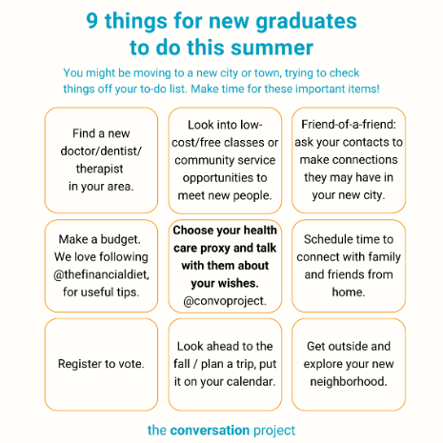
Option #3
You may be planning on moving out of your family home this summer, or maybe you're just moving to a new city and want some tips on handling a fresh start.
If you've recently graduated from college/high school/ or took a job in a different place, you probably have a checklist (or multiple checklists) of things you have to do. Make time for these important items too!
And if you're over 18, one thing we can help you with is making sure you've chosen a health care proxy and documented and talked about what your wishes are with the person you've chosen to speak for you in the event that you can't make your wishes heard yourself.
Read through @The Conversation Project’s guide to Choosing Your Health Care Proxy: https://bit.ly/39xSmYM

X/Twitter:
Additional hashtags (to consider based on post/character space):
#SummerTravel #SummerTime #EOL #ACP #AdvanceCarePlanning #SummerRoadTrip #ConversationStarters
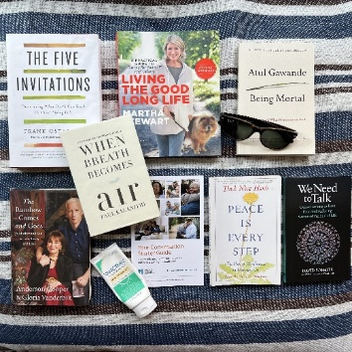
Option #1
Looking for something to add to your #summer reading list this year? Here are a few of our favorites that we recommend, including @convoproject’s Conversation Starter Guide to inspire some #conversations with the people who matter most to you. What would you add?
https://theconversationproject.org/tcp-blog/12-must-read-books-about-death-and-end-of-life-care/
Additional account tags to tag authors in post (usually done in a Twitter thread):
.@andersoncooper @HarperCollins @Atul_Gawande @picadorbooks @penguinrandom @rocketgirlmd @thichnhathanh @fostaseski @fiveinvitations @Flatironbooks @MarthaStewart @ClarksonPotter
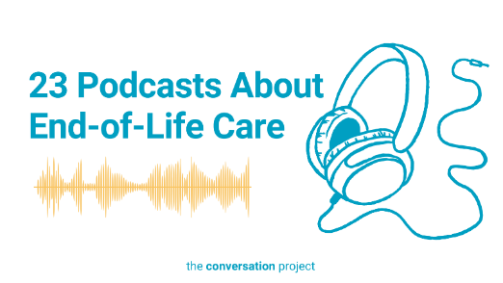
Option #2
Hitting the road this #summer and taking a much-needed break?
One thing you can do in the car, on the plane, or on a blanket soaking up the sun, is listen to a #podcast Check out @convoproject’s blog, 23 Podcasts About End-of-Life Care: https://theconversationproject.org/tcp-blog/16-podcasts-about-end-of-life-care/
Additional account tags to tag authors in post (usually done in a Twitter thread):
.@meekamartina @DrReginaKoepp @AlexSmithMD @GeriPalBlog @JwshSacredAging @NPRLifeKit @libsyn @sherylsmithrn @CTACorg @DreamNationLove @AlicaForneret @onbeing @985TheSportsHub @Stitcher @HiddenBrain @cianna @thedeathdeck

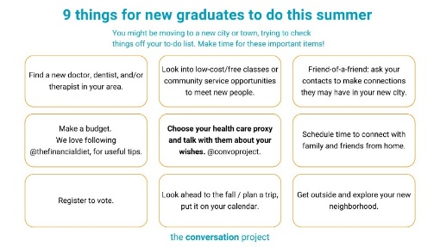
Option #3
If you've recently graduated from college, high school, or took a job in a different place, you probably have a checklist (or multiple checklists) of things you have to do. Make time for these important items too!
On choosing a health care proxy: https://bit.ly/39xSmYM
Other messages/images to use across social media from the Serious Illness Messaging Toolkit*:
Talk to the people who matter most about the care you want.
The more you speak up, the better your health care can be.
We’ll figure this out together.
Let’s make a plan for your care.

*A toolkit created in partnership during a three-year grant generously funded by The John A. Hartford Foundation and Cambia Health Foundation. Whether you want to steal and use the above messages 'as-is', or edit them to fit your organization's needs, or use them as inspiration, these messages are meant for you to steal. The only ask is that you take the time to really understand how the five messaging principles, detailed in the toolkit, come into play (so that you don't add in words we intentionally left out!). For more on the messaging principles, free messages, images and text, click this link and download the toolkit.
Be sure to tag, follow, and reshare content from The Conversation Project’s Instagram, Facebook, and X/Twitter accounts if you are looking for more content outside of this toolkit to support the theme: “Conversations on the Go – Summertime Travel”. We’ll be posting this and more, all of which you are welcome to adapt to your own usage.
@convoproject | @TheConversationProject | @convoproject

What do you think of this Toolkit? Please help us and take 2 minutes to answer 3 questions in our brief survey here.

