Community Champion Communications Toolkit

Theme: Supporting Self

Suggested timeframe: December-January
Instructions for toolkits can be found here. Please adapt any/some/all of the below as you wish!
The end of every year is often a busy time, with little time for self. This theme’s goal is to help folks in your community take a step back – and for you to offer up some inspiration, motivation, and resources – for their self-reflection about what matters most.
And, as a proud champion of The Conversation Project, we encourage YOU to “walk the talk” – by first thinking about this for yourself – to be better equipped to support others in your community to plan ahead!

Sample messaging to be adapted and used in newsletters, email, flyers or other mass send outs
Rest, rejuvenate, and ready yourself for important conversations
The end of every year is often a busy time, with little time for self. As this year ends and a new one begins, we encourage you to take a step back and carve out some “me time.” Support yourself by reflecting on what matters most to you in your life and in your health care. Starting with inner reflection and personal thinking time can help us prepare for these important conversations over time with those important people in our lives.
Check out The Conversation Project’s Get Started page for free resources to 1) help you think about your values and health care wishes, and then 2) get ideas on how to start talking about and understanding the health care wishes of other important people in your life. We hope this helps you to make some action-oriented resolutions this new year!

Sample text/images to be adapted as you wish: for Social Media or Use in Newsletters, Flyers, Emails, etc. (instructions for use here, including downloading images)

The following examples are tailored to three social media platforms (Instagram, Facebook, X (Twitter) but can be used/adapted more broadly in other social media platforms and/or other communications methods you use.

Instagram:
Option #1
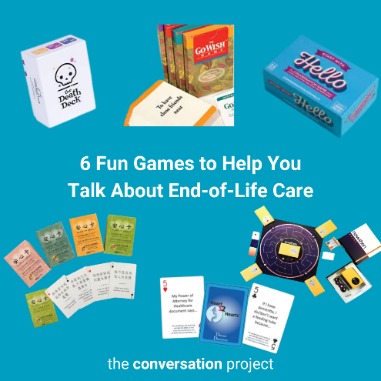
The holidays are always a great time to gather those who are close in your life and start or continue conversations about what matters most in your and their life. And what better way to help you think about what is most important in your life and in your health than playing a game! Check out @convoproject’s list of games to help you think about and talk about care through the end of life.
🔗 Go visit the link in our bio/visit the linktree in our bio to read the full blog: "6 Fun Games to Help You Talk About End-of-Life Care"
Link to add to your bio/linktree: https://theconversationproject.org/tcp-blog/death-is-not-a-game-well-sometimes-it-is/

Additional hashtags to copy and paste into your first Instagram comment:
#WMTY #TCP #TheConversationProject #FreeResources #caregiver #caregiving #SeriousIllness #Family #SeriousIllness #CancerCare #CancerCaregiver #TalkingAboutCancer #chf #Parkinsons #Alzheimers #AlzCaregivers #Dementia #Lupus #als #COPD #DementiaCaregiver #ALS #ALSCaregivers #CysticFibrosis #HIV #Palliative #PalliativeCare #CaregiverLife #ElderCare #WhatMatterstoYou #WhatMattersMost #powerofattorney #SupportingSelf #SupportingYourself #Selfcare #fun #games #endoflife #games #holidayseason #deathdeck #deatheducation #gamesnight #cardgames #boardgames #conversationstarters #endoflifewishes #eolcare #Wouldyourather #familydinner #holidaydinner
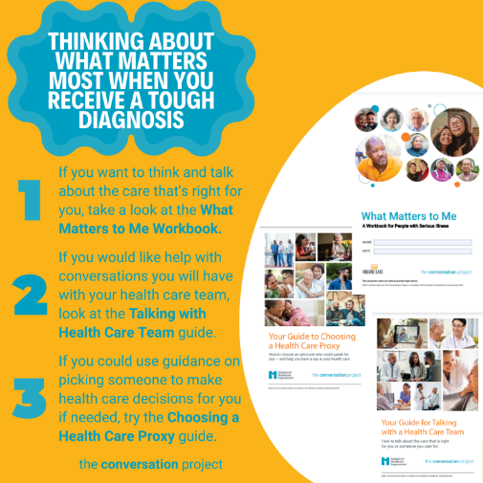
Option #2
Being diagnosed with a serious illness is tough. How are you taking care of self? Taking time to think about what matters to you, in your life and in your health can be chicken soup for your soul.
@convoproject has a blog and free guides listed in this image that include tips and free resources to help you think about what matters most to you in your own care. This way, you can start to think about what's important to you.
🔗 Go visit the link in our bio/visit the linktree in our bio to read the full blog: I received a tough diagnosis. How do I think and talk about what’s important in my care?
Link to add to your bio/linktree: https://theconversationproject.org/tcp-blog/i-received-a-tough-diagnosis-how-do-i-think-and-talk-about-whats-important-in-my-care/
Additional hashtags to copy and paste into your first Instagram comment:
#Selfcare #WMTY #whatmatters #TCP #TheConversationProject #FreeResources #FreeGuides #Blogs #medicalcare #eolwishes #conversationstarter #conversation #caregiver #caregiving #SeriousIllness #SuddenDiagnosis #Family #SeriousIllness #CancerCare #CancerCaregiver #TalkingAboutCancer #chf #Parkinsons #Alzheimers #AlzCaregivers #Dementia #MS #Lupus #als #COPD #DementiaCaregiver #ALS #ALSCaregivers #CysticFibrosis #HIV #Palliative #PalliativeCare #CaregiverLife #ElderCare #WhatMatterstoYou #WhatMattersMost #powerofattorney #SupportingSelf #SupportingYourself
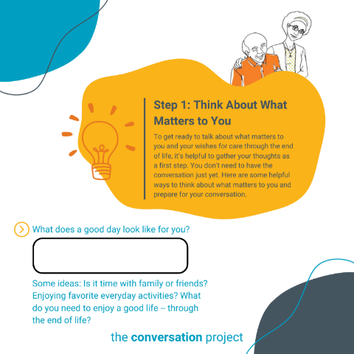
Option #3
Haven’t had time to think about what's important to you? Grab a coffee and one of @convoproject’s free Conversation Starter guides and spend some quality, self-reflection time to think about what matters to you in your life and in your health care.
🔗 Go visit the link in our bio/visit the linktree in our bio to access @convoproject’s Conversation Starter Guide.
Link to add to your bio/linktree: https://theconversationproject.org/wp-content/uploads/2020/12/ConversationStarterGuide.pdf
Additional hashtags to copy and paste into your first Instagram comment:
#TheConversationProject #TCP #CaregiverAdvice #SelfCare #SupportingSelf #ConversationStarter #FreeResources #FreeGuides #Blogs #medicalcare #eolwishes #conversation #caregiver #caregiving #SeriousIllness #WhatMatterstoYou #WhatMattersMost #powerofattorney #SupportingSelf #SupportingYourself
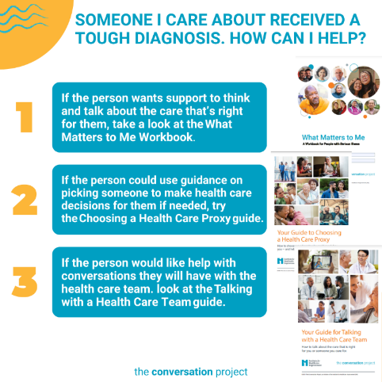
Option #4
If someone you care about is dealing with a serious illness, you may want some ideas for how to talk with and support them, including finding good support for yourself.
🔗 Go visit the link in our bio/visit the linktree in our bio to read a few suggestions from @convoproject in: A Guide to Supporting Others through a Difficult Diagnosis
Link to add to your bio/linktree: https://theconversationproject.org/tcp-blog/a-guide-to-supporting-others-through-a-difficult-diagnosis/
Additional hashtags to copy and paste into your first Instagram comment:
#TCP #TheConversationProject #Conversation #Caregiver #Caregiving #SeriousIllness #WhatMatterstoMe #WhatMattersMost #ConversationGuide #StartingTheConversation #SuddenDiagnosis #Family #SeriousIllness #CancerCare #CancerCaregiver #TalkingAboutCancer #chf #Parkinsons #Alzheimers #AlzCaregivers #Dementia #MS #Lupus #als #COPD #DementiaCaregiver #ALS #ALSCaregivers #CysticFibrosis #HIV #Palliative #PalliativeCare #CaregiverLife #ElderCare #powerofattorney #SupportingSelf #SupportingYourself #Selfcare
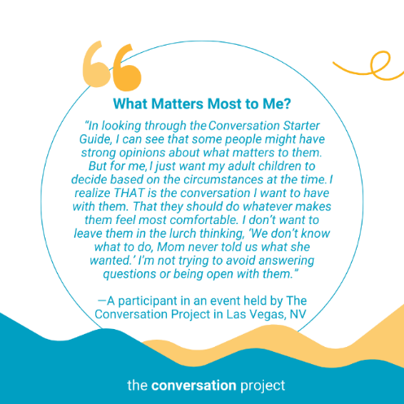
Option #5
Holiday bustle means doing a lot for many. Don't forget to support yourself to better support others. Think about what matters most to you, in life and in your health.
As this participant from one of The Conversation Project’s events explains, there’s no one right answer to landing on the right conversation for you about what matters most in your care.
“In looking through the Conversation Starter Guide, I can see that some people might have strong opinions about what matters to them. But for me, I just want my adult children to decide based on the circumstances at the time. I realize THAT is the conversation I want to have with them. That they should do whatever makes them feel most comfortable. I don’t want to leave them in the lurch thinking, ‘We don’t know what to do, Mom never told us what she wanted.’ I’m not trying to avoid answering questions or being open with them.”
- A participant in an event held by The Conversation Project in Las Vegas, NV
🔗 Go visit the link in our bio/visit the linktree in our bio to read @convoproject’s blog: Real-life examples of people talking about what matters for their health care
Link to add to your bio/linktree: https://theconversationproject.org/tcp-blog/real-life-examples-of-people-talking-about-what-matters-for-their-health-care/
Additional hashtags to copy and paste into your first Instagram comment:
#TCP #TheConversationProject #FreeGuides #HealthCareProxy #Choosingaproxy #cancercare #talkingaboutcancer #chf #parkinsons #alzheimers #dementia #als #COPD #cysticfibrosis #conversation #caregiver #caregiving #SeriousIllness #WhatMattersToMe #WhatMattersMost #healthcareagent #parent #spouse #momofteens #family #powerofattorney #accidentrecovery #rehabilitation #accidentsurvivor #SupportingSelf #SupportingYourself #Selfcare
Facebook:
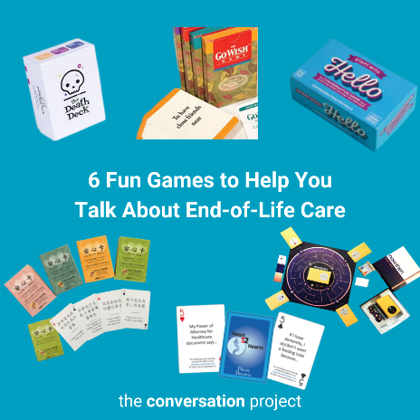
Option #1
The holidays are always a great time to gather those who are close in your life and start or continue conversations about what matters most in your and their life. And what better way to help you think about what is most important in your life and in your health than playing a game!
Read about more games in @TheConversationProject blog, "6 Fun Games to Help You Talk About End-of-Life Care" here: https://theconversationproject.org/tcp-blog/death-is-not-a-game-well-sometimes-it-is/

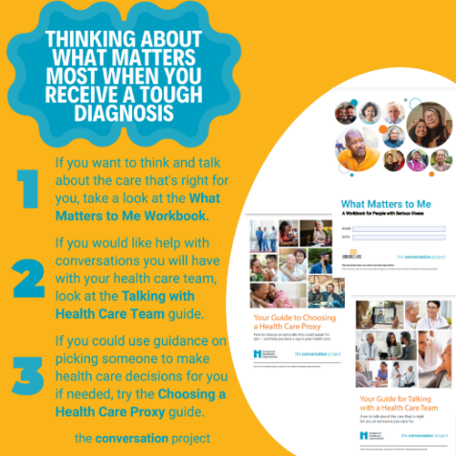
Option #2
Being diagnosed with a serious illness is tough. How are you taking care of self? Taking time to think about what matters to you, in your life and in your health can be chicken soup for your soul.
@TheConversationProject has a blog and our free guides listed in this image that include tips and free resources to help you think about what matters most to you in your own care. This way, you can start to think about what's important to you.
Follow the link below to read the full blog: I received a tough diagnosis. How do I think and talk about what’s important in my care? #Selfcare
https://theconversationproject.org/tcp-blog/i-received-a-tough-diagnosis-how-do-i-think-and-talk-about-whats-important-in-my-care/

Option #3
Haven't had time to think about what's important to you? Grab a coffee and one of @TheConversationProject’s free guides and spend some quality, self-reflection time to think about what matters to you in your life and health. #Selfcare
https://theconversationproject.org/wp-content/uploads/2020/12/ConversationStarterGuide.pdf
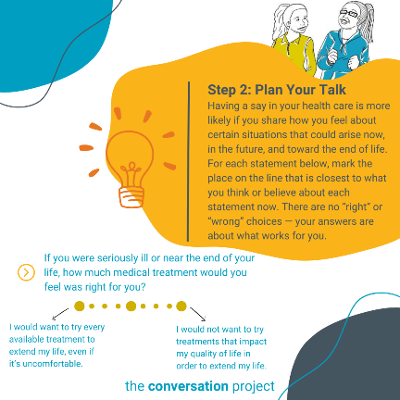
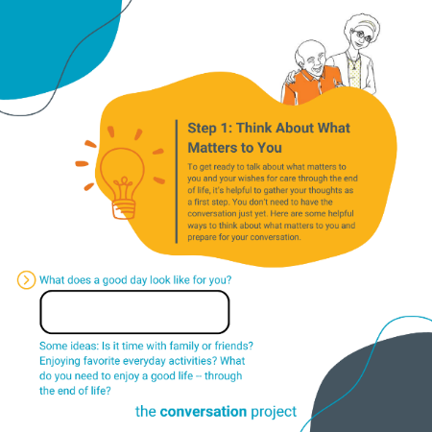

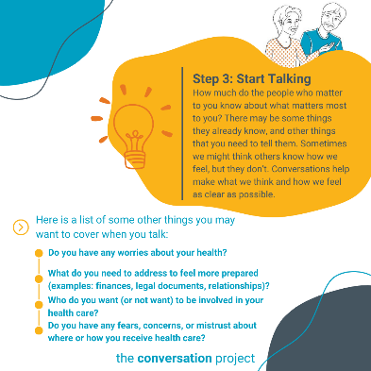
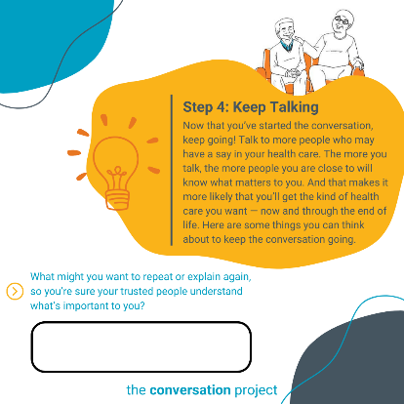
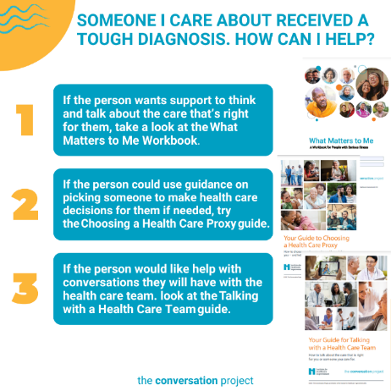
Option #4
If someone you care about is dealing with a serious illness, you may want some ideas for how to talk with and support them.
@TheConversationProject has a few suggestions for getting started, including finding good support for yourself: https://theconversationproject.org/tcp-blog/a-guide-to-supporting-others-through-a-difficult-diagnosis/ #Selfcare

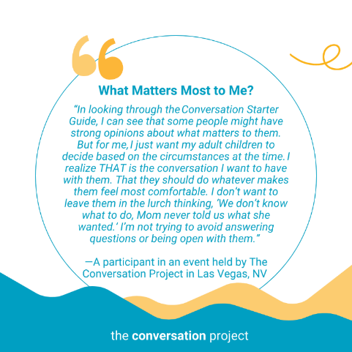
Option #5
Holiday bustle means doing a lot for many. Don't forget to support yourself to better support others. Think about what matters most to you, in life and in your health.
As this participant from one of The Conversation Project’s events explains, there’s no one right answer to landing on the right conversation for you about what matters most in your care.
“In looking through the Conversation Starter Guide, I can see that some people might have strong opinions about what matters to them. But for me, I just want my adult children to decide based on the circumstances at the time. I realize THAT is the conversation I want to have with them. That they should do whatever makes them feel most comfortable. I don’t want to leave them in the lurch thinking, ‘We don’t know what to do, Mom never told us what she wanted.’ I’m not trying to avoid answering questions or being open with them.”
- A participant in an event held by The Conversation Project in Las Vegas, NV
@convoproject has more real life examples of what people like you or I talk about when it comes to what matters most in their health care in their blog: https://theconversationproject.org/tcp-blog/real-life-examples-of-people-talking-about-what-matters-for-their-health-care/ #SelfCare

X (Twitter):
Additional hashtags (to consider based on post/character space):
#Support, #Self, #Planning, #AdvanceCarePlanning, #WhatMatters, #Caregiver, #Caregivers, #Palliative, #hcsm

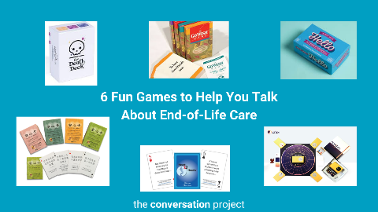
Option #1
If you’re looking for something fun to play with the important people in your life over the holidays, here’s a list from @convoproject to get you started! #Selfcare #WMTY
https://theconversationproject.org/tcp-blog/death-is-not-a-game-well-sometimes-it-is/
Option #2
Haven't had time to think about what's important to you? Grab a coffee and @convoproject’s free Conversation Starter Guide and spend time thinking about what matters to you in your life and health #Selfcare #WMTY
https://theconversationproject.org/wp-content/uploads/2020/12/ConversationStarterGuide.pdf
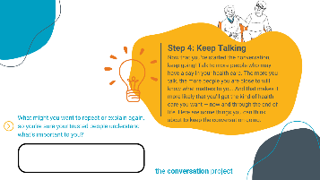
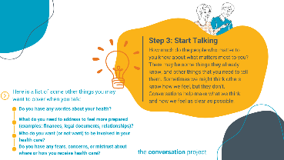
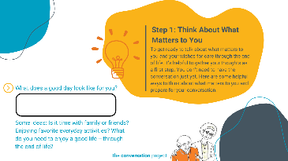
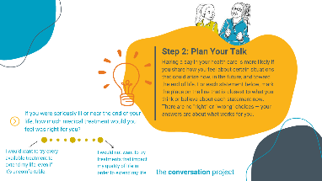
NOTE: This asset is meant to be posted as a carousel or uploaded as multiple images in one. You may choose to only post some of the options in the carousel.
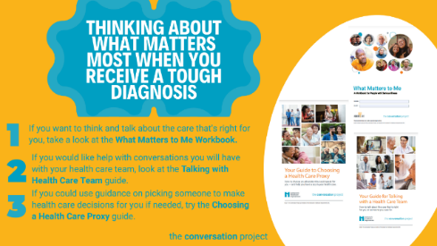
Option #3
Being diagnosed with a #seriousillness is tough. How are you taking care of self? Taking time to think about #whatmatters to you, in your life and health, can be chicken soup for your soul. @convoproject has a blog with tips to help you #SelfCare #WMTY https://theconversationproject.org/tcp-blog/i-received-a-tough-diagnosis-how-do-i-think-and-talk-about-whats-important-in-my-care/

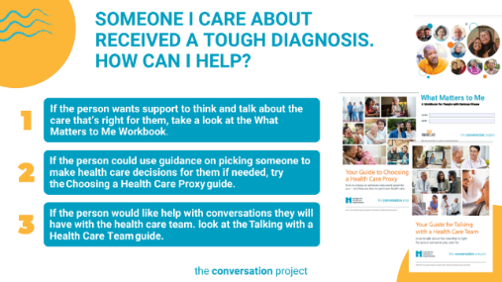
Option #4
If someone you care about is dealing with a #seriousillness, you may want some ideas for how to talk with and support them.
@convoproject has a few suggestions for getting started, including finding good support for yourself. #Selfcare #caregivers https://theconversationproject.org/tcp-blog/a-guide-to-supporting-others-through-a-difficult-diagnosis/

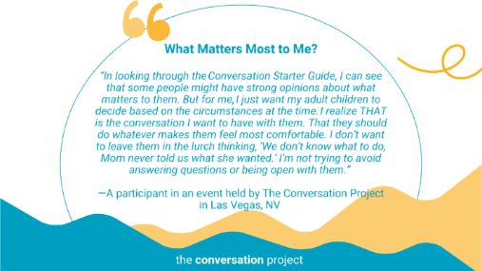
Option #5
Holiday bustle means doing a lot for many. Don't forget to support yourself to better support others. Think about what matters most to you, in life and in your health.
@convoproject has a resource to help you think. #Selfcare #WMTY
https://theconversationproject.org/tcp-blog/real-life-examples-of-people-talking-about-what-matters-for-their-health-care/

Other messages/images to use across social media from the Serious Illness Messaging Toolkit*:

You can have a say in your care.
Treatments only work if they work for you.

*A toolkit created in partnership during a three-year grant generously funded by The John A. Hartford Foundation and Cambia Health Foundation. For more free messages, images and text, click this link and download the toolkit.
Be sure to tag, follow, and reshare content from The Conversation Project’s Instagram, Facebook, and Twitter accounts if you are looking for more content outside of this toolkit to support the theme: “Supporting Self”. We’ll be posting this and more, all of which you are welcome to adapt to your own usage.
@convoproject | @TheConversationProject | @convoproject

What do you think of this Toolkit? Please help us and take 2 minutes to answer 3 questions in our brief survey here.

