National Healthcare Decisions Day Communications Toolkit
Theme: Talk about it
There is no “one size fits all” when it comes to planning for and participating in National Healthcare Decisions Day (NHDD). While the day itself falls on April 16th, many groups chose to start promoting NHDD earlier to whet the appetite and/or continue celebrating past April 16th to promote ongoing conversations about what matters most when it comes to our care wishes. No matter what you do or when you start, the common theme we suggest is simply to “talk about it.”
And what better way to start, by starting with self to better be able to support others. Thinking about what is important to you and then talking about it with those important to you, those who may need to speak up for you if you are unable at any point. And then use your story of how it went for you when you help others to talk about what’s important to them.
Looking for ideas for planning for and promoting National Healthcare Decisions Day (NHDD) in your community? We’ve pulled together some of our most frequently asked questions about planning for NHDD and created a roadmap with specific examples and resources to help provide answers.
Whatever you decide to do in honor of NHDD is MUCH appreciated. And don’t forget, if you host an event and you use social media, share it on your platforms and tag us so we can help spread the word.
Please adapt any/some/all of the below as you wish!
Standard newsletter, email, flyer, or other mass send out language about NHDD
National Healthcare Decisions Day (sometimes referred to as NHDD) is an annual initiative celebrated on April 16th to encourage and empower people to begin conversations about their wishes for care through the end of life.
NHDD is both for individuals and community leaders. The date was set in 2008, by attorney Nathan Kottkamp, based on the Benjamin Franklin quote that “[I]n this world, nothing is certain except death and taxes.” So, do your taxes each year by the 15th and review your health care wishes each year on the 16th. We want to normalize reviewing this each year and recognize that wishes or the people in your life may change.
Over time it has grown into a national series of independent events hosted through the month of April by hundreds of community groups: health care systems, legal services, faith-based organizations, book clubs… you name it, someone has brought it to that audience.
This year – we invite you to set April 16th as the date by which you plan to have a conversation with someone important in your life about your, or their, wishes. Maybe you can bring it out a layer and normalize this with people in your social network – or your employer or faith community. As you know, these aren’t just conversations we have with doctors and lawyers, and we don’t have to wait until we’re sick to have them.
The Conversation Project, an initiative of the Institute for Healthcare Improvement, has LOTs of free resources to help you have these conversations or share this idea in your community. Let us know how we can help.
Be an influencer in your own communities!
This year, we want to encourage you all to be gen-influencers in your own communities. Identify your platforms and audiences to reach and influence those in your own life to start conversations about the kind of care they want through the end of life, and the decisions they may want to make based on those wishes. We don’t have to wait until NHDD to start thinking or even talking about our wishes but remember that our capacity to influence starts with ourselves. Take some time if you haven’t already to start to think and talk about your wishes for care through the end of life.
Logo(s):
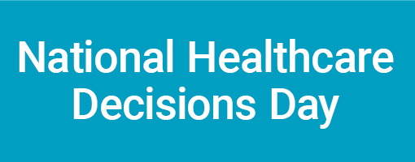
Hashtags
#NationalHealthcareDecisionsDay, #NationalHealthcareDecisionsDay2024, #NHDD, #NHDD2024

Sample text/images: for Social Media Posts or For Use in Newsletters, Flyers, Emails, etc.

The following examples are tailored to three social media platforms (Instagram, Facebook, X(Twitter)) but can be used/adapted more broadly in other social media platforms and/or other communications methods you use. We’ll have daily themes the week leading up to April 16th and will be posting about each one every day, so keep an eye out for these posts and be sure to retweet/repost/share our content!
Instructions on how to use these sample posts:
- In the Instagram section, you will see the following copy highlighted: “🔗 Go visit the link in our bio/visit the linktree in our bio...” Use this if you actively link to a linktree account in your Instagram account bio. If not, you can delete the linktree-specific text.
- In the Instagram section, the reusable hashtags are meant to be for your use in every post, following the theme of this toolkit. Please feel free to modify or use alternative hashtags as you see fit.
  - If you want to use the hashtags suggested under each Instagram post, we suggest you include these in a first comment under the post itself once you’ve uploaded it. The same can be done on X (Twitter) if you are scheduling the post ahead of time with a third-party app such as sproutsocial – once you’ve posted, you can include more hashtags in a comment on the image itself (this would start a thread under the image with the hashtags or accounts you wish to tag)
- To download the images found in the toolkit, right click on the image and hit “save as” to save it as a JPEG or PNG file on your computer. Note each image was designed for the specifications of the noted platform – ensure you use the correct one. And, feel free to use these in other communications or platforms you use.
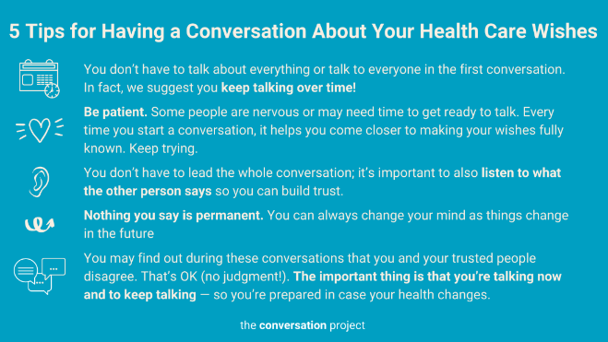
X (Twitter)
Option 1
This #NHDDWeek starts with YOU! Dedicate time to reflect and talk about what matters most to you. Here are 5 tips to help you turn this theme into action! Check out @convoproject free Conversation Starter Guide or What Matters to Me Workbook. https://bit.ly/3rEvFI1

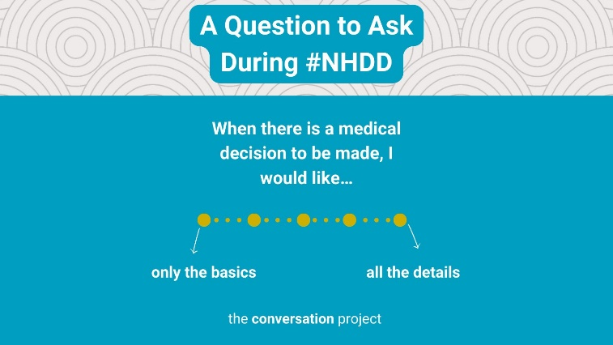
Option 2
As #NHDD approaches, think about the questions you might want to be asking yourself about the type of care you would want through the end of life. Read more in @convoproject @AriadneLabs @CambiaHealthFdn What Matters to Me Workbook: https://bit.ly/31RWwWy

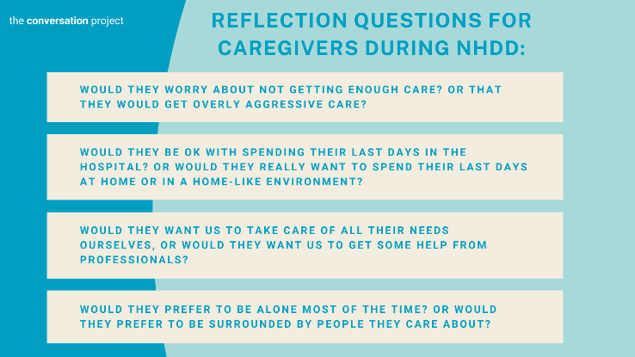
Option 3
This #NHDD, show love to those in your life/community who care for others! Consider sending them @convoproject guides. Example: Conversation Starter Guide for Caregivers of People with #Alzheimer’s or Forms of #Dementia https://bit.ly/3rwnbmB

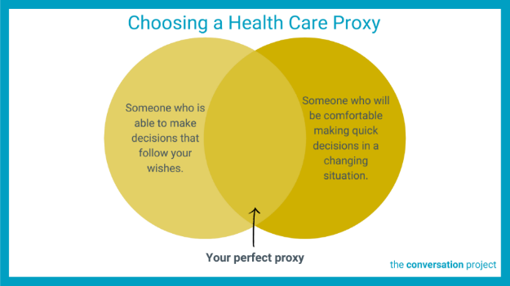
Option 4
Who is your person for #NHDD? Choosing a health care proxy who not only knows your wishes but will also ensure that they're honored is so important! Who in your life do you trust to speak for you? Check out @convoproject free tool https://bit.ly/39xSmYM @NHDD

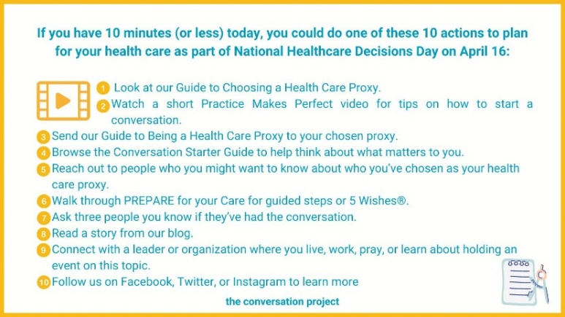
Option 5
If you have 10 minutes (or less) today, you could do one of these 10 actions to plan for your health care as part of #NationalHealthcareDecisionsDay #NHDD on April 16th! Read more in @convoproject’s blog here: https://bit.ly/3OedZjc
ACCOUNTS TO TAG IN POST: @5WishesOrg @prepareforcare @CoPractice @CACforCC @thedeathdeck @theaftercommnty @CODAalliance

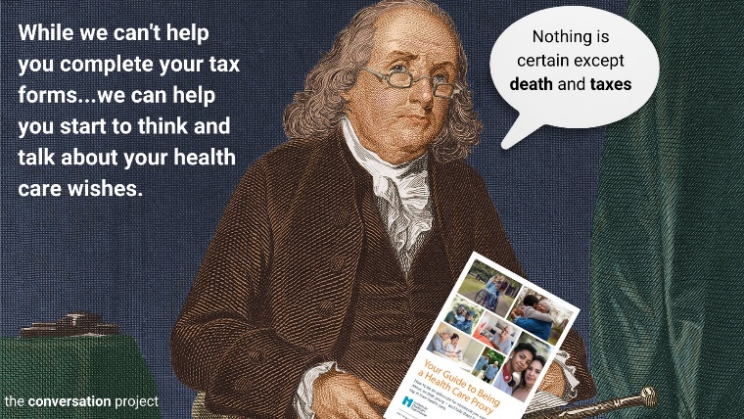
Options 6
Tax season can be daunting, but starting conversations about your health care wishes doesn't have to be.
@Convoproject is here to help! Read through their guide to Being a Health Care Proxy: https://bit.ly/2YtTG8E

Facebook
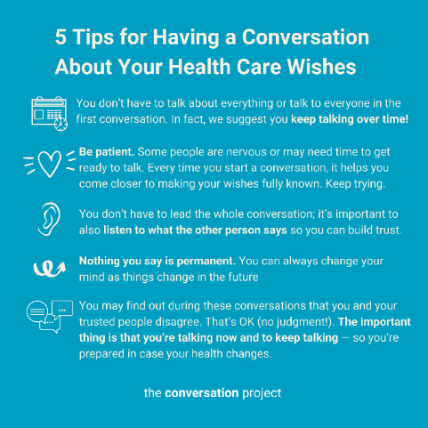
Option 1
This #NHDDWeek starts with YOU! Dedicate time to reflect and talk about what matters most to you. Below are 5 tips @TheConversationProject compiled to help you turn this theme into action! For more guidance, visit @TheConversationProject website to access their free Conversation Starter Guide or What Matters to Me Workbook to help you think through your values and who you would want to share your healthcare wishes with. @NHDD https://bit.ly/3rEvFI1 #NHDD

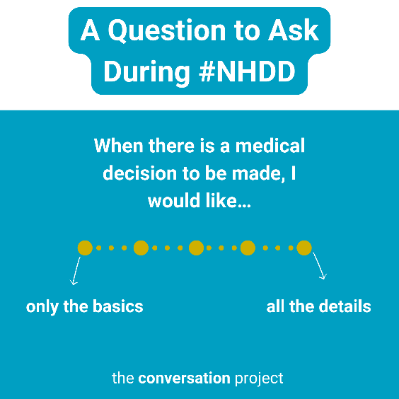
Option 2
As #NHDD approaches, think about the questions you might want to be asking yourself about the type of care you would want through the end of life. If you'd like, start to test out feeler questions with the people closest to you, like the ones we have in our What Matters to Me Workbook for those living with serious illness.
Read more in @TheConversationProject What Matters to Me Workbook: https://bit.ly/31RWwWy
Many thanks to Ariadne Labs and The Cambia Health Foundation for collaborating on this resource.

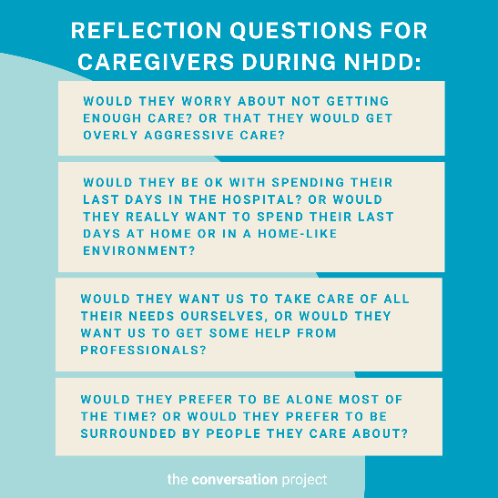
Option 3
We're just a few weeks away from #NHDD, let's use this time to focus on supporting caregivers. Show love to those in your life/community who care for others! Consider sending them @TheConversationProject following guides: Conversation Starter Guide for Caregivers of People with Alzheimer’s or Forms of Dementia and/or Conversation Starter Guide for Caregivers of a Child with Serious Illness.
@TheConversationProject free guides For Caregivers of People with Alzheimer’s or Other Forms of Dementia and For Caregivers of a Child with Serious Illness are specifically designed for caregivers. Check them out or share them with a caregiver in your life!
https://bit.ly/4cf3fNe

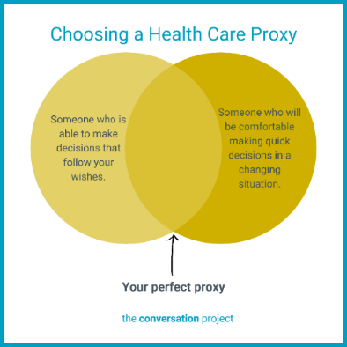
Option 4
Who is your person for #NHDD? Choosing a health care proxy who not only knows your wishes but will also ensure that they're honored is so important! Who in your life do you trust to speak for you? Check out @TheConversationProject free tool https://bit.ly/39xSmYM @NHDD

Option 5
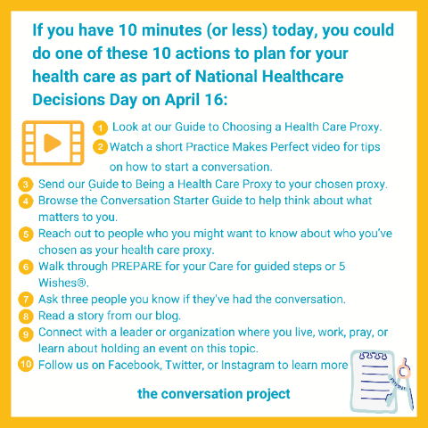
If you have 10 minutes (or less) today, you could do one of these 10 actions to plan for your health care as part of National Healthcare Decisions Day (@NHDD) on April 16:
1. Look at @TheConversationProject’s Guide to Choosing a Health Care Proxy.
2. Watch a short Practice Makes Perfect video for tips on how to start a conversation: https://youtu.be/d_vbGD0UBzs
3. Send the Guide to Being a Health Care Proxy to your chosen proxy.
4. Browse the Conversation Starter Guide to help think about what matters to you.
5. Reach out to people who you might want to know about who you’ve chosen as your health care proxy.
6. Walk through PREPARE for your Care for guided steps or 5 Wishes®.
7. Ask three people you know if they’ve had the conversation.
8. Read a story from @TheConversationProject’s blog.
9. Connect with a leader or organization where you live, work, pray, or learn about holding an event on this topic.
10. Follow @TheConversationProject on Facebook, Twitter, or Instagram to learn more.
Read more in @TheConversationProject’s blog: https://bit.ly/3OedZjc

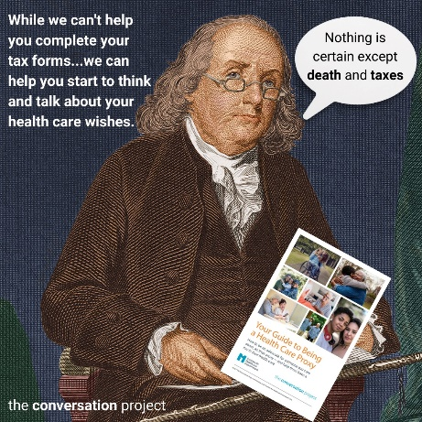
Option 6
Tax season can be daunting, but starting conversations about your health care wishes doesn't have to be. @TheConversationProject is here to help!
Start by reading through their guide to Being a Health Care Proxy: https://bit.ly/2YtTG8E

Instagram
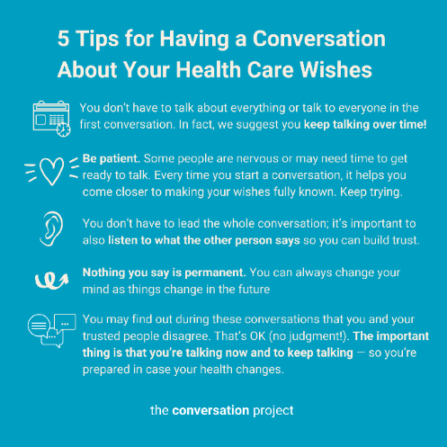
Option 1
This NHDD week starts with YOU! Dedicate time to reflect and talk about what matters most to you. Below are 5 tips @convoproject compiled to help you turn this theme into action!
🔗 Go visit the link in our bio/visit the linktree in our bio to read through @convoproject’s free Conversation Starter Guide or What Matters to Me Workbook.
Link to add to your bio/linktree: https://theconversationproject.org/get-started#Your-Conversation-Starter-Guide
Additional hashtags to copy and paste into your first Instagram comment:
#NHDD #NHDDWeek #NationalHealthcareDecisionsDay #advancecareplanning #advancedirective #planningahead #havetheconversation #conversationproject #theconversationproject #convoproject #palliative #palliativecare #hospice #hospicecare #clinicians #estateplanning #livingwill #powerofattorney #eol #endoflife #eolplanning #endoflifeplanning #eolcare #endoflifecareplanning #communityinfluencer #carewishes

Option 2
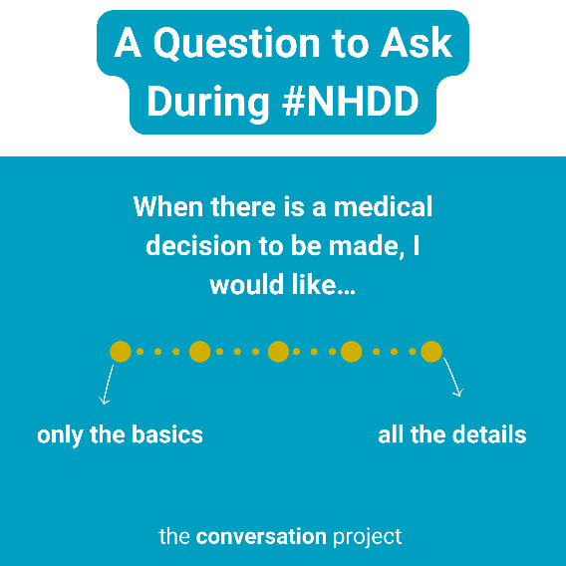
As NHDD approaches, think about the questions you might want to be asking yourself about the type of care you would want through the end of life. If you'd like, start to test out feeler questions with the people closest to you, like the ones we have in our What Matters to Me Workbook for those living with serious illness.
🔗 Go visit the link in our bio/visit the linktree in our bio to read through @convoproject’s free resource: What Matters to Me Workbook in collaboration with @AriadneLabs and @cambiahealth.
Link to add to your bio/linktree: https://theconversationproject.org/get-started#For-Caregivers-of-a-Child-with-Serious-Illness
Additional hashtags to copy and paste into your first Instagram comment:
#TheConversationProject #TCP #NationalHealthcareDecisionsDay #NationalHealthcareDecisionsDay2024 #NHDD #NHDD2024 #planningahead #advancecareplanning #acp #planningahead #eolplanning #endoflifeplanning #estateplanning #estate #healthcaredecisions #healthcareproxy #proxy
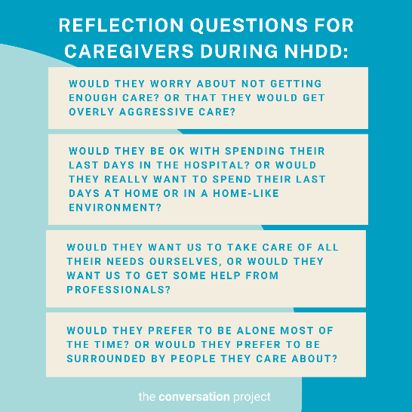
Option 3
NHDD is only a few days away, let's use this time to focus on supporting caregivers. Show love to those in your life/community who care for others! Consider sending them our following guides: Conversation Starter Guide for Caregivers of People with Alzheimer’s or Forms of Dementia and/or Conversation Starter Guide for Caregivers of a Child with Serious Illness.
📘 @convoproject’s free guides For Caregivers of People with Alzheimer’s or Other Forms of Dementia and For Caregivers of a Child with Serious Illness are specifically designed for caregivers. Check them out or share them with a caregiver in your life!
🔗 Go visit the link in our bio/visit the linktree in our bio to read @convoproject’s free guides.
Link to add to your bio/linktree: https://theconversationproject.org/get-started#For-Caregivers-of-People-with-Alzheimer%E2%80%99s-or-Other-Forms-of-Dementia
Additional hashtags to copy and paste into your first Instagram comment:
#NHDD #NationalHealthcareDecisionsDay #advancecareplanning #advancedirective #planningahead #havetheconversation #conversationproject #theconversationproject #convoproject #palliative #palliativecare #hospice #hospicecare #clinicians #estateplanning #livingwill #powerofattorney #eol #endoflife #eolplanning #endoflifeplanning #eolcare #endoflifecareplanning #caregiver #caregiversupport #caregivers #caregiving #caregiverlife #caregivertips #caregivingfortheelderly

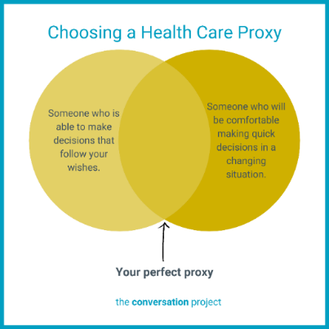
Option 4
Who is your person for #NHDD? Choosing a health care proxy who not only knows your wishes but will also ensure that they're honored is so important! Who in your life do you trust to speak for you?
🔗 Go visit the link in our bio/visit the linktree in our bio to read through @convoproject’s free resource: Your Guide to Choosing a Health Care Proxy.
Link to add to your bio/linktree: https://theconversationproject.org/get-started#Who-Will-Speak-For-You?-How-to-choose-and-be-a-health-care-proxy

Additional hashtags to copy and paste into your first Instagram comment:
#proxy #healthcareproxy #agent #healthcareagent #doctor #primarydoctor #physicianassistant #nurse #specialitst #therapist #socialworker #psychologist #casemanager #addmittingteam #palliative #palliativecare #palliativecarespecilaist #palliativecareteam #conversationproject #convoproject #theconversationproject
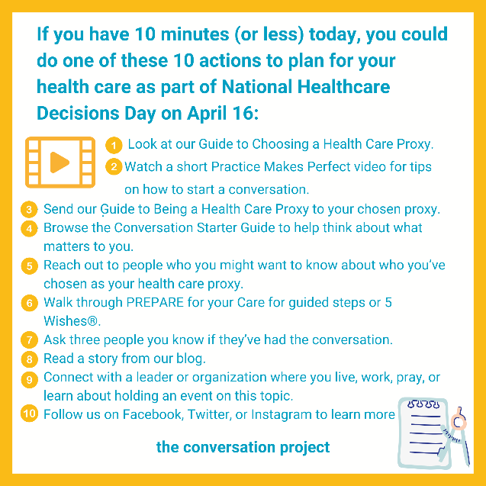
Option 5
If you have 10 minutes (or less) today, you could do one of these 10 actions to plan for your health care as part of #NationalHealthcareDecisionsDay #NHDD on April 16th!
🔗 Go visit the link in our bio/visit the linktree in our bio to read @convoproject’s 10 Ideas of Things to Do for National Healthcare Decisions Day (in 10 Minutes or Less)
Link to add to your bio/linktree: https://theconversationproject.org/tcp-blog/10-ideas-of-things-to-do-for-national-healthcare-decisions-day-in-10-minutes-or-less/
Additional hashtags to copy and paste into your first Instagram comment:
#NHDD #NHDD2024 #nationalhealthcaredecisionsday #nationalhealthcaredecisionsday2024 #theconversationproject #tcp #healthcareproxy #conversationstarters #conversationstartersforfamilies #whatmatterstoyou

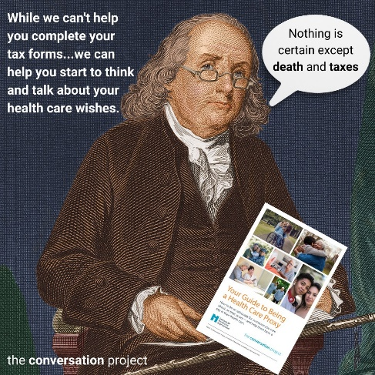
Option 6
We are getting close to National Healthcare Decisions Day (NHDD)! Ben Franklin and the @convoproject team want to remind you that NHDD is one day after tax day here in the U.S.. Tax season can be daunting, but starting conversations about your health care wishes doesn't have to be. @convoproject is here to help! Start by reading through their guide to being a health care proxy.
🔗 Go visit the link in our bio/visit the linktree in our bio to read @convoproject’s guide to Being a Health Care Proxy.
Link to add to your bio/linktree: https://theconversationproject.org/wp-content/uploads/2020/12/BeAProxyGuide.pdf

90-second video: What is National Healthcare Decisions Day and How Can I Participate?
Click here for more information and a link to this video that you can use as you wish.
Other messages/images to use across social media from the Serious Illness Messaging Toolkit*:

You can have a say in your care
Treatments only work is they work for you.
Talk to the people who matter most about the care you want.
The more you speak up, the better your health care can be.
Tell your doctors what matters most to you.
You can get the care that’s right for you.

We’ll figure this out together.
Let’s make a plan for your care.

*A toolkit created in partnership during a three-year grant generously funded by The John A. Hartford Foundation and Cambia Health Foundation. For more free messages, images and text, download the toolkit here.
------------------------------------------------------------------------------------------------------------------------------------
Be sure to tag, follow, and reshare content from National Healthcare Decisions Day and The Conversation Project’s Instagram, Facebook, and X (Twitter) accounts if you are looking for more content outside of this toolkit to support NHDD. We’ll be posting this and more, all of which you are welcome to adapt to your own usage.
@convoproject | @TheConversationProject  @NationalHealthcareDecisionsDay | @convoproject  @NHDD

For additional messaging and images, see our previous toolkits following other themes here.
For a list of and links to 25 potential resources to share for NHDD, see this blog.
What do you think of this Toolkit? Please help us and take 2 minutes to answer 3 questions in our brief survey here.

