Standard Newsletter Language About NHDD
National Healthcare Decisions Day (NHDD) is an initiative to encourage people to express their wishes regarding healthcare and for providers and facilities to respect those wishes, whatever they may be. It’s important to understand that NHDD is not only about end-of-life care but is meant to reach a much broader spectrum so that every individual may have their healthcare wishes met. Click here to learn more!

Logo(s):
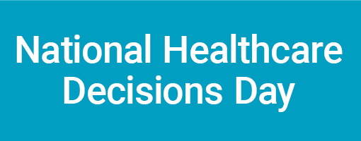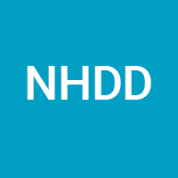
Hashtags
#NationalHealthcareDecisionsDay
#NationalHealthcareDecisionsDay2022
#NHDD
#NHDD2022

Pre-NHDD Social Media Posts
- Twitter:
  - #NHDD is on April 16th! Need help planning? @convoproject has compiled 5 creative ideas to get your wheels turning! https://bit.ly/3fMatxr @NHDD
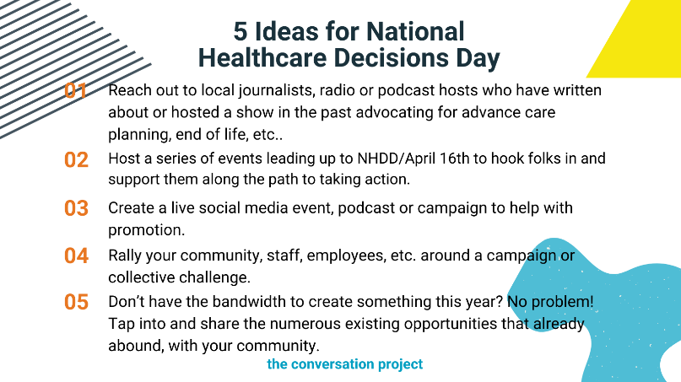
  - #NHDD exists to inspire educate and empower the public about the importance of advance care planning conversations. This year, you can join the #NHDD2022 movement by following any of these 3 steps! @NHDD @convoproject. https://bit.ly/31SmlWM

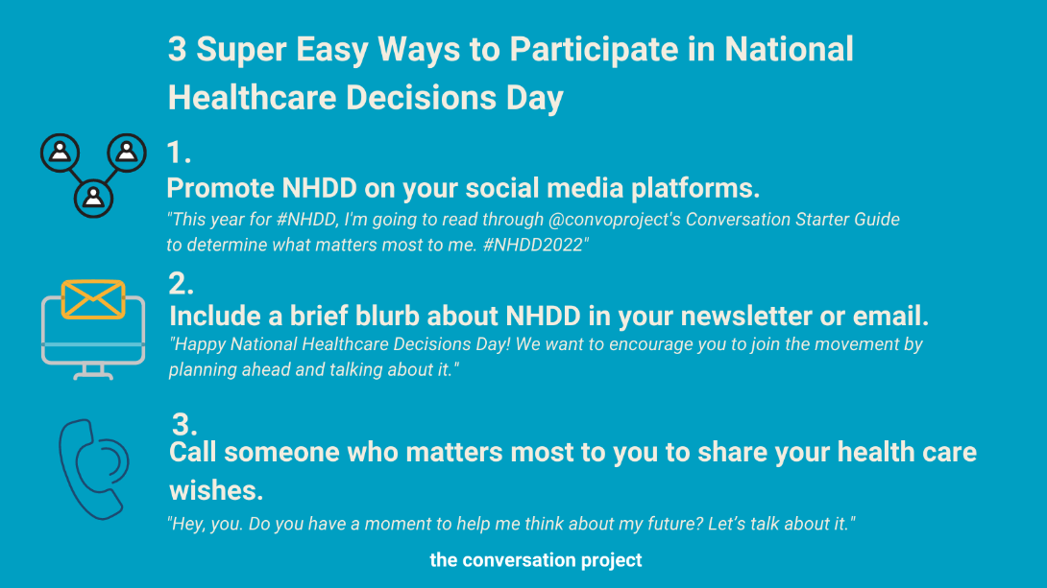

  - This year, #NHDD falls on a Saturday! That gives us the perfect chance to line up #NHDD related activities all week long. @convoproject compiled a list of themes to help you participate in this movement and tap on others to join in too! #NHDD2022 @NHDD https://theconversationproject.org/get-started
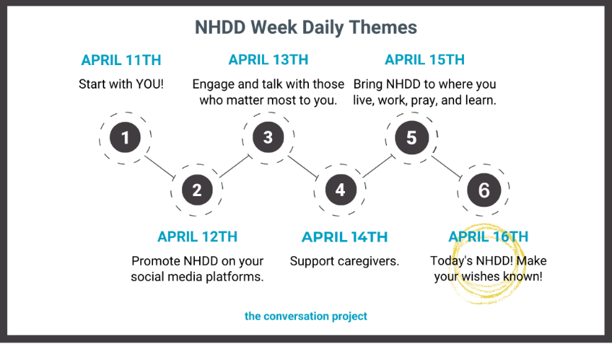
OR
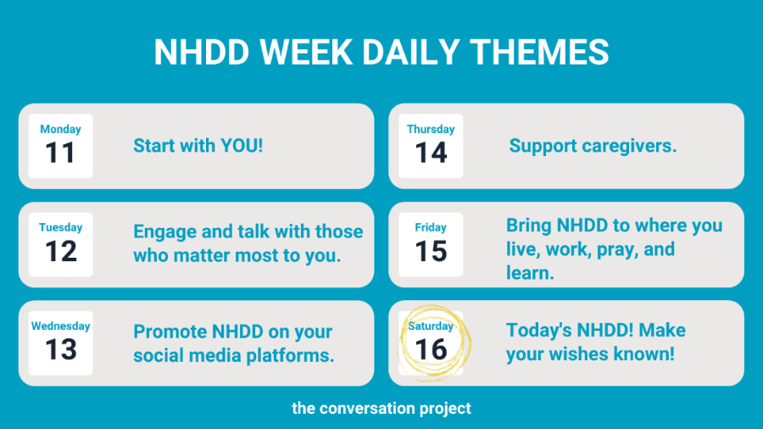

Facebook & Instagram
*The yellow highlights indicate the social media platform that corresponds with either the social media handle or hashtag listed.
- (Facebook: @NationalHealthcareDecisionsDay) (Instagram: #NationalHealthcareDecisionsDay) is less than a month away! And, given these complicated times, many people feel creatively stunted and are unsure as to how they can participate in the #NHDD movement. Well, (Facebook @TheConversationProject) (Instagram: @convoproject) has compiled 5 ideas to help get your creative juices flowing! If you’re looking for exciting ways to get involved in NHDD 2022, read their blog that includes five inspirational ideas from groups who led and continue to execute successful #NHDD2022 activities! https://bit.ly/3b5dLt1
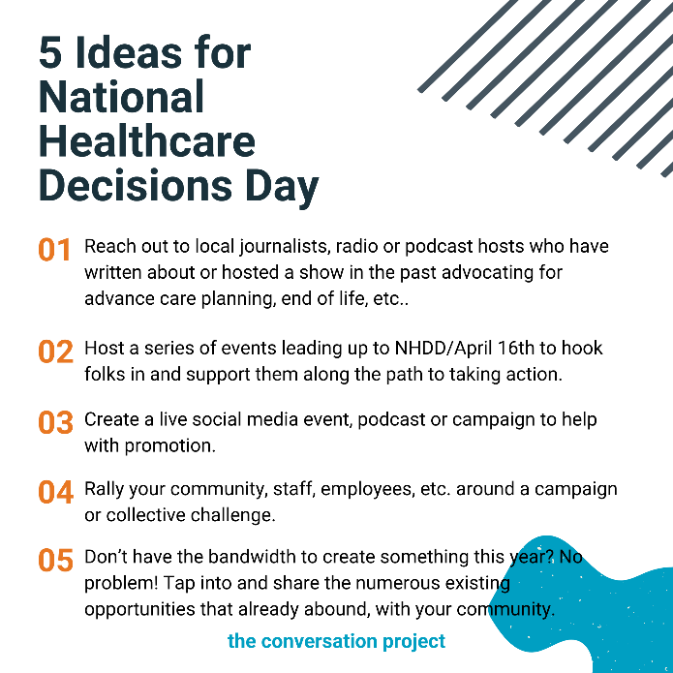
- #NHDD exists to inspire educate and empower the public about the importance of advance care planning. This year, you can join the #NHDD2022 movement by following all or any of these 3 easy steps!

- Promote NHDD on your social media platforms. "This year for #NHDD, I'm going to read through @convoproject's Conversation Starter Guide to determine what matters most to me. #NHDD2022"
- Include a brief blurb about NHDD in your newsletter or email. "Happy National Healthcare Decisions Day! We want to encourage you to join the movement by planning ahead and talking about it."
- Call someone who matters most to you to share your health care wishes. "Hey, you. Do you have a moment to help me think about my future? Let’s talk about it."

(Facebook: @NationalHealthcareDecisionsDay @TheConversationProject) (Instagram: @convoproject). https://bit.ly/31SmlWM

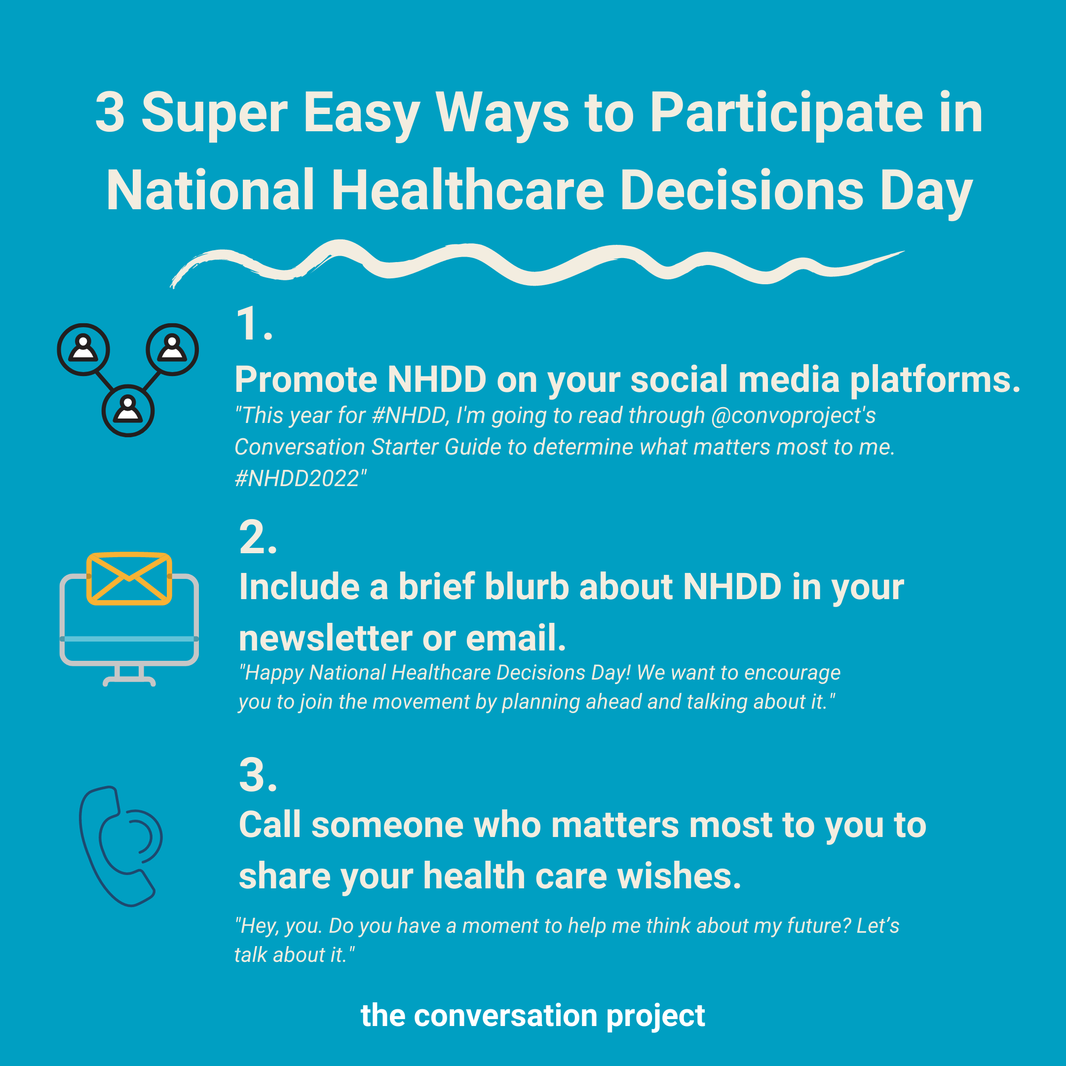

- #NationalHealthcarDecisionsDay is quickly approaching! With that, (Facebook: @TheConversationProject) (Instagram: @convoproject) wants to remind you of the themes they’ll be highlighting throughout the week of #NHDD. During #NHDD week, they will share relevant resources for you to share with your community/network! These themes are also designed to help you participate in this important movement and tap on others to join in too! Visit their website for all the resources mentioned below: https://bit.ly/3rEvFI1

April 11th: Start with YOU (self)! Dedicate this day to reflecting on what matters most to you. Check out our Conversation Starter Guide or What Matters to Me Workbook to help you think through your values and who you would want to share your healthcare wishes with.

April 12th: Promote NHDD on your social media platforms. You can use this time to inform your family, friends, and followers about #NHDD. Feel free to post our free guides and resources to your own platforms as well – you can find all this content directly on our website!

April 13th: Engage and talk with those who matter most to you. Meet up with a friend, call a family member or send someone from your faith community a text message to get the conversation started. The theme of this day is intended to encourage you to share what matters most to you with those who matter most to you.

April 14th: Support caregivers. Show love to those in your life/community who care for others! Consider sending them our following guides: Conversation Starter Guide for Caregivers of People with Alzheimer’s or Forms of Dementia and/or Conversation Starter for Caregivers of a Child with Serious Illness.

April 15th: Bring #NHDD to where you live, work, pray and learn. Healthcare professionals, clergy, professional service orgs/individuals (estate attorneys, elder care lawyers, financial planners, etc.), colleges/universities, high schools, etc., during this day, lead/host events and raise awareness about #NHDD within your network/community.

April 16th: NHDD has arrived! Make your wishes known! Talk about it, write a letter, and share any other resources that will help you and others jump start a conversation to make your wishes known.
