Standard Newsletter Language About NHDD
National Healthcare Decisions Day (NHDD) is an initiative to encourage people to express their wishes regarding healthcare and for providers and facilities to respect those wishes, whatever they may be. It’s important to understand that NHDD is not only about end-of-life care but is meant to reach a much broader spectrum so that every individual may have their healthcare wishes met. Click here to learn more!
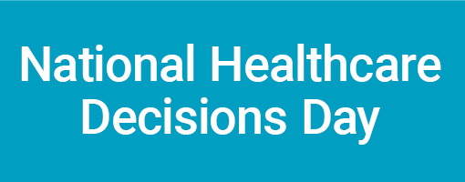
Logo
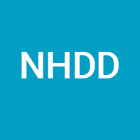

Hashtags
#NationalHealthcareDecisionsDay
# NationalHealthcareDecisionsDay2021
#NHDD
#NHDD2021
Pre-NHDD Social Media Posts
- Twitter:
  - #NHDD is on April 16th! Need help planning? @convoproject has compiled 5 creative ideas to get your wheels turning! https://bit.ly/3fMatxr @NHDD
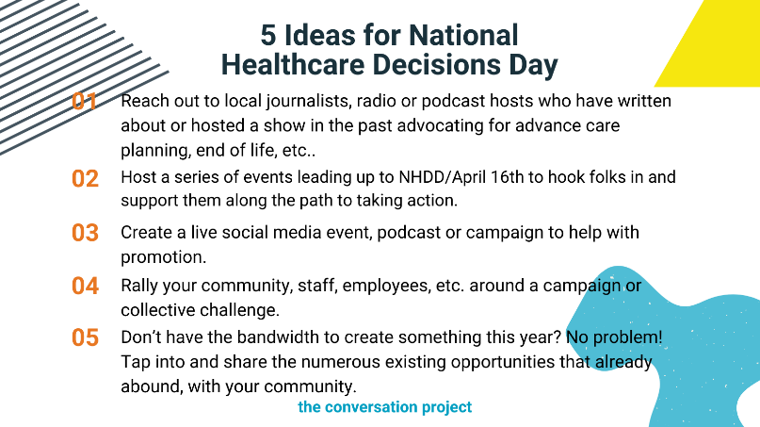

  - #NHDD exists to inspire educate and empower the public about the importance of advance care planning. This year, join the #NHDD2021 movement by starting a conversation about advance care planning with people in your community/network! @NHDD @convoproject. https://bit.ly/31SmlWM
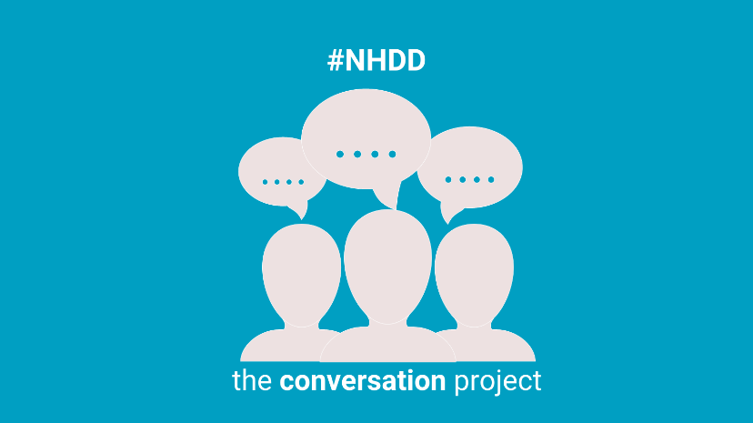

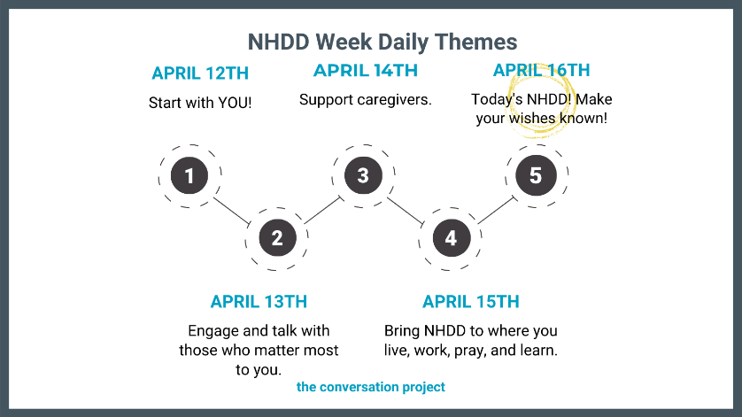
- This year, #NHDD falls on a Friday! This is the perfect chance to celebrate #NHDD all week long. @convoproject compiled a list of daily themes to help you participate in this important movement and tap on others to join in too! #NHDD2021 @NHDD

Facebook & Instagram
*The yellow highlights indicate the social media platform that corresponds with either the social media handle or hashtag listed.
- (Facebook: @NationalHealthcareDecisionsDay) (Instagram: #NationalHealthcareDecisionsDay) is less than a month away! And, given these complicated times, many people feel creatively stunted and are unsure as to how they can participate in the #NHDD movement. Well, (Facebook @TheConversationProject) (Instagram: @convoproject) has compile 5 ideas to help get your creative juices flowing! If you’re looking for exciting ways to get involved in NHDD 2021, read their blog that includes five inspirational ideas from groups who led and continue to execute successful #NHDD2021 activities! https://bit.ly/3b5dLt1
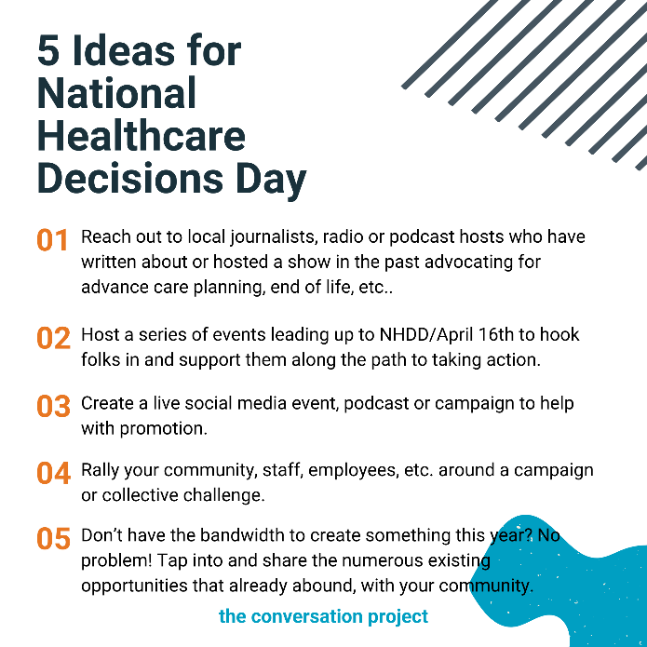

- #NHDD exists to inspire educate and empower the public about the importance of advance care planning. This year, join the #NHDD2021 movement by starting a conversation about advance care planning with people in your community/network! (Facebook: @NationalHealthcareDecisionsDay @TheConversationProject) (Instagram: @convoproject). https://bit.ly/31SmlWM
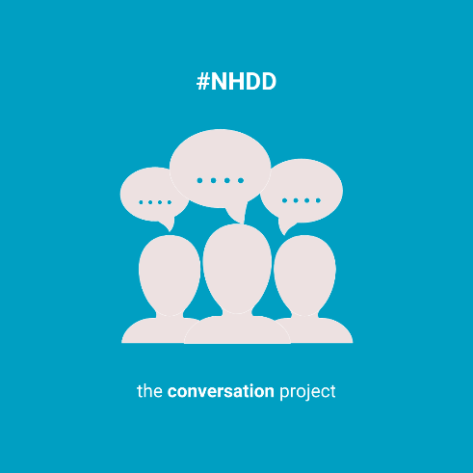

- As #NationalHealthcarDecisionsDay is quickly approaching! With that, (Facebook: @TheConversationProject) (Instagram: @convoproject) want to remind you of the themes they’ll be highlighting throughout the week of #NHDD. During #NHDD week, they will share relevant resources for you to share with your community/network! These themes are also designed to help you participate in this important movement and tap on others to join in too! Visit their website for all the resources mentioned below: https://bit.ly/3rEvFI1

April 12th: Start with YOU (self)! Dedicate this day to reflecting on what matters most to you. Check out our Conversation Starter Guide or What Matters to Me Workbook to help you think through your values and who you would want to share your healthcare wishes with.

April 13th: Engage and talk with those who matter most to you. Meet up with a friend, call a family member or send someone from your faith community a text message to get the conversation started. The theme of this day is intended to encourage you to share what matters most to you with those who matter most to you.

April 14th: Support caregivers. Show love to those in your life/community who care for others! Consider sending them our following guides: Conversation Starter Guide for Caregivers of People with Alzheimer’s or Forms of Dementia and/or Conversation Starter for Caregivers of a Child with Serious Illness.

April 15th: Bring #NHDD to where you live, work, pray and learn. Healthcare professionals, clergy, professional service orgs/individuals (estate attorneys, elder care lawyers, financial planners, etc.), colleges/universities, high schools, etc., during this day, lead/host events and raise awareness about #NHDD within your network/community.

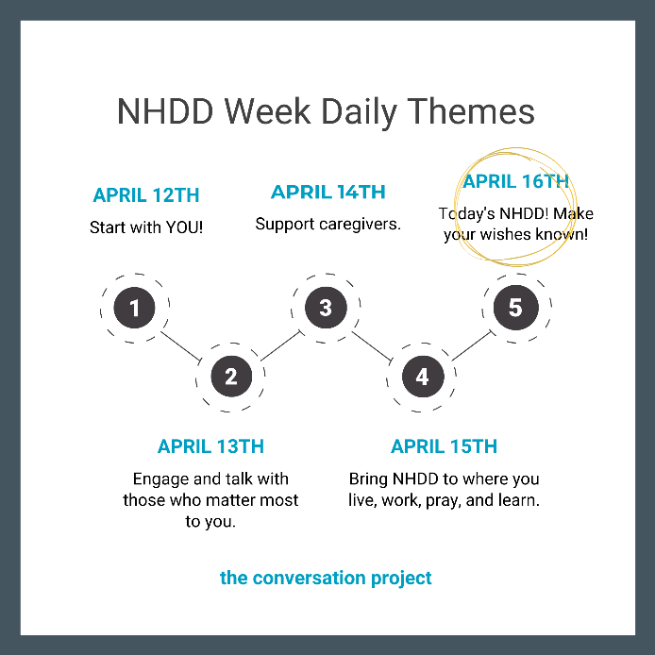
April 16th: NHDD has arrived! Make your wishes known! Share, letters, and any other resources that will help you and others make your wishes known.

