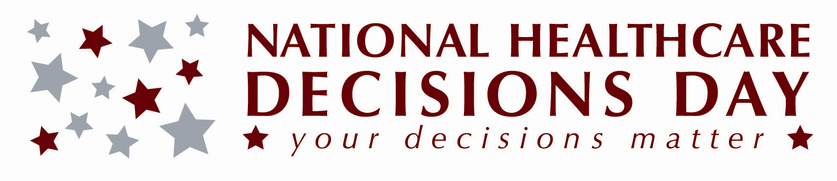

For Immediate Release:
[List date]

National Healthcare Decisions Day Set for April 16

(List your city, state) - [List your organization], along with other national, state and community organizations, are leading a massive effort to highlight the importance of advance healthcare decision-making—an effort that has culminated in the formal designation of April 16 as National Healthcare Decisions Day (NHDD). As a participating organization, [list your organization] is providing information and tools for the public to talk about their wishes with family, friends and healthcare providers, and execute written advance directives (healthcare power of attorney and living will) in accordance with [List your state] state laws. These resources are available at [List your web site or contact information and/or list http://nhdd.org].

Specifically, on April 16, from ___ to ___ [List time], [List organization] is welcoming the public throughout the day at [List location], with free information about advance care planning and advance directive forms. [Include more information about any special event here].

As a result of National Healthcare Decisions Day, many more people in our community can be expected to have thoughtful conversations about their healthcare decisions and complete reliable advance directives to make their wishes known. Fewer families and healthcare providers will have to struggle with making difficult healthcare decisions in the absence of guidance from the patient, and healthcare providers and facilities will be better equipped to address advance healthcare planning issues before a crisis and be better able to honor patient wishes when the time comes to do so.

For more information about National Healthcare Decision Day, please visit http://nhdd.org.

-###-

Media Contact: [List name, organization, phone number, email]

