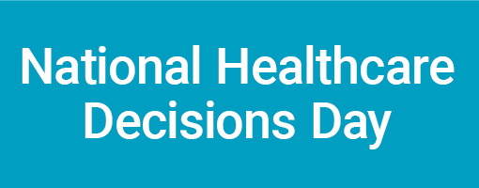

The following Op. Ed. is available for your organization to place in local newspapers, community magazines, consumer newsletters and organizational newsletters. The article is non-exclusive, which means any newspaper can run it, and you are free to use it in whatever way you deem appropriate.

Join National Healthcare Decisions Day…Because Your Decisions Matter

Please help us make history, again. April 16, 2010, will be the third annual National Healthcare Decisions Day. The inaugural event, which was formally recognized by Congress and numerous state and local governments, included participation by 76 of the most prominent national healthcare, religious, and legal associations and organizations. By the second year, we over 700 local and state organizations throughout the country also participated. At every level, the goal of this nationwide initiative is to ensure that all adults with decision-making capacity in America have both the information and the opportunity to communicate and document their future healthcare decisions. The first years’ results were impressive—over 750,000 people obtained resources to make their healthcare decisions known—but there remain millions of Americans to go.

While making healthcare decisions is often difficult in the best of circumstances, making decisions for others is even more complicated. Each of us has the ability to guide our healthcare providers and our loved ones about what we want. Advance directives give you the ability to document the types of healthcare you do and do not want, and to name an “agent” to speak for you if you cannot speak for yourself. As Terri Schiavo’s situation vividly revealed, having an advance directive can be valuable for all adults, regardless of current age or health status.

With the Patient Self-Determination Act of 1990, Congress affirmed the right of every citizen to set forth his or her future healthcare wishes in writing with an “advance directive.” Yet, various estimates suggest that only about 25% of all Americans have done so. Because advance directives can be created without a lawyer, for free, and relatively easily, this figure is astonishingly low. In recognition of this, National Healthcare Decisions Day strives to provide much-needed information to the public, reduce the number of tragedies that occur when a person’s wishes are unknown, and improve the ability of healthcare facilities and providers to offer informed and thoughtful guidance about advance healthcare planning to their patients.

Please visit www.NHDD.org for a variety of free information (including free advance directives forms for every state) and tools to assist with thoughtful reflection on healthcare choices and ideas on how to get involved. Additionally, watch for events in your community honoring National Healthcare Decisions Day. Finally, please share this information with your loved ones and colleagues.

With healthcare, “your decisions matter,” however, others need to know your wishes to honor them. There are no wrong answers when thinking about healthcare choices and completing an advance directive. Please use April 16, 2010, to decide, discuss, and document your wishes, whatever they may be.

Nathan A. Kottkamp
Chair, National Healthcare Decisions Day

