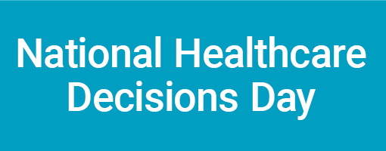
Get Involved in National Healthcare Decisions Day -- April 16

[List your organization], along with other national, state and community organizations, is leading a massive effort to highlight the importance of advance healthcare decision-making—an effort that has culminated in the formal designation of April 16 as National Healthcare Decisions Day (NHDD).

NHDD organizers are asking interested organizations and individuals throughout the country to help raise awareness about the importance of advance care planning on this special day—and throughout the year. To help realize this goal, they have created a Web site with information and tools for the public to talk about future healthcare decisions and execute written advance directives (healthcare power of attorney and living wills) in accordance with their applicable state laws.

The Web site (NHDD.org) also includes tips on how advocates can raise awareness in their communities. In addition to signing up your organization to participate, here are some of the ways [List your organization] members can help this important cause:

- First and foremost, lead by example…be sure you have thoughtfully considered and made your own healthcare decisions known.
- Next, make sure everyone in your organization is informed about NHDD (including staff, board of directors, volunteers and others) and ask for their involvement to promote NHDD in your community. (Suggestion: Have staff wear a button that says “Ask Me About Advance Directives!”)
- Provide a link on your organizational Web site to NHDD.org. It features a variety of information for the public and providers on advance care planning.
- Set up an exhibit about NHDD at your main entrance and offer information about advance care planning as people come by.
- Distribute NHDD promotional materials and advance care planning educational brochures at upcoming community events or health fairs.
- Partner with your community library to set up a display highlighting books about advance healthcare decision-making and use NHDD promotional resources.
- Partner with local retail businesses by asking them to place a promotional flyer about NHDD in every bag.
- Distribute flyers about NHDD in local physician offices and other strategic locations such as elevators in public buildings.
- Encourage your state leaders to establish a state-sanctioned, secure on-line advance directive registry.
- Contact local media (newspapers, TV, and radio) and encourage them to write a piece about NHDD and advance healthcare planning.

Although several states have engaged in advance directives awareness events and numerous organizations have devoted substantial time and money to improving education about advance healthcare planning, only a small minority of Americans has executed an advance directive. NHDD seeks to address this issue by focusing attention on advance healthcare planning from a variety of directions simultaneously.

Organizations and coalitions interested in participating are encouraged to sign up at the NHDD Web site. State coordinators are also being recruited to develop statewide networks and outreach activities. For details, visit NHDD.org.

