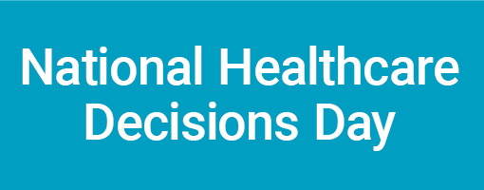
Obtaining Participant Feedback
We suggest that you use the Participant Feedback Form for your NHDD event. It is easiest to hand out and collect the form at the event. Using the form for follow-up feedback several weeks after the event is harder, but gives better information about the longer term impact.
To use the Participant Feedback Form at your event:
- Modify the form if necessary to make it work for your event.

- Give the form to participants at the beginning of the event. (Include in the handout, place on the chair, or pass them around after everyone is seated) That way even those who have to leave early will have a chance to provide their feedback.

- Make sure that you ask participants to complete the form and tell them how you will use the information – to improve your events, and to document the impact of NHDD. Assure them that they can remain anonymous and let them know that their opinion is important.

- If possible, provide a box near the exit for the completed surveys so that they do not have to hand them to you.

If you choose to mail the Participant Feedback Form out after the event, the following are suggestions to enhance your response. Please note that you will likely get fewer responses than if you distribute it at the event.
- Ask people attending events to sign in and provide an email address – then you can contact them later to find out what impact the event had on them.
- At the event, have participants self-address an envelope (to themselves) and drop it in a box provided. Sometime after the event, send them the feedback form (or an abbreviated version on a stamped post card) in the envelope they addressed. They can fill it out and send it back. If you send the full size form, be sure to provide an addressed, stamped envelope for return.
- Add a cover letter, or a paragraph at the top of the feedback form reminding participants about the event and asking them for feedback. It is also helpful to tell them how you will use the information - to improve your events, and to document the impact of NHDD.
Participant Feedback Form
[Insert name of your group and/or the event] [Insert date of event]
- Did you have an advance directive prior to attending this event? Yes No

- What was your main reason for attending this event?
- I am currently coping with an end-of-life situation in my personal life
- I want to be prepared for the future
- I am concerned about the availability of quality end-of-life care in the community
- I thought it sounded interesting
- I was invited by a friend, family member, or colleague
- Other: __________________________________________________

- What was your overall impression of the information provided? (Check the statement that best applies)
- I learned many new things that will be useful to me
- I learned a few new things that will be useful to me
- I learned new things, but nothing of use to me
- I did not learn anything new, but it was a good review
- I did not learn anything new and was disappointed
- Other: ____________________________________________________

- After attending this event, which of the following are you likely to do within the next month or two? (Check all that apply)
  - More thinking and/or reading about this topic
  - Talk to family members and/or close friends about this topic
  - Talk with my doctor about this topic
  - Talk with the leader or someone in my faith community about this topic
  - Complete an advance directive form or written statement of my wishes
  - Update my advance directive form or written statement of my wishes
  - Help someone I know to complete an advance directive form or written statement of end-of-life wishes
  - Get involved in efforts to improve end-of-life care in the community
  - Other: _______________________________________________________

- Are there things you expected or hoped to hear about that did not come up in the discussion? NO YES (explain _____________________________________)

- Additional comments:

- Please provide some demographic information:
Male Female 35 or younger 36-50 50-65 66 or older
Race/ Ethnicity: _____________________________________

