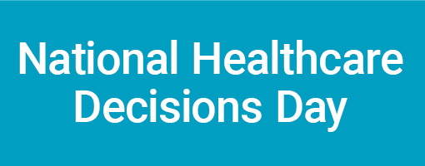

Likely media questions and suggested responses:

Why is National Healthcare Decisions Day happening?

NHDD exists to “to inspire, educate and empower the public and providers about the importance of advance care planning.”

Why is NHDD targeted at the public and providers?

All adults should discuss and document their healthcare wishes in the event of a crisis. Accidents and acute illness can happen to anyone at any time, but far too few adults have done anything to plan ahead.

It is well known that providers can do a better job of raising the topic of advance care planning and incorporating patient’s wishes into their delivery of care.

NHDD offers a chance to address both these populations at the same time.

Why is NHDD on April 16?

It was inspired by Benjamin Franklin’s quip that “nothing in life is certain but death and taxes.”

Is NHDD only about end-of-life decisions?

No. NHDD encourages all adults to discuss and document their wishes for any event in which they cannot speak for themselves.

How many Americans have engaged in advance are planning?

Various studies suggest that only about a quarter of all adults have engaged in advance care planning.

Is it difficult to engage in advance care planning?

No. There are all sorts of free tools that are available to start and structure the conversations, and free advance directive forms for every state and several particular interests are available to document the discussion. These are all available at www.nhdd.org. Specifically, the short videos are an excellent way to start the conversation with loved ones.

The hardest part is often just raising the topic, which is how NHDD can help. It creates a reason to “have the talk” and provides the tools to do it.

Do I need a lawyer to create an advance directive (living will, health care power of attorney, etc)?

No. Free forms and information are available for every state at www.nhdd.org. Also, every hospital in the US is required to provide patients about advance directives, so you can always ask at your local hospital.

Are you doing this to encourage people not to seek aggressive care?

Absolutely not. We want to encourage people to discuss and document their wishes so that they get the right care for them. For some patients this may mean aggressive care and for others it means nothing more than managing pain.

How can people help?

First, lead by example. Do your own advance care planning. Then, let others know about it. For your loved ones, you want to be sure they know your wishes. For everyone else, it is good enough to say you’ve done it. Then, encourage all those contacts to do the same. NHDD is a grassroots initiative, and we can use all the help we can get to spread the word. You can share on Facebook (www.facebook.com/nationalhealthcaredecisionsday) or on Twitter @NHDD/#NHDD. Be creative.

