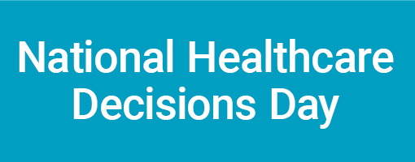

Event Planning Checklist

Event Planning Assignments | Timeline | Person/s Responsible | Task  Completed
Confirm event date and time | 3-6 months
Develop a budget | 3-6 months
Reserve event location | 3-6 months
Contact potential sponsors if needed | 3-6 months
Identify target audiences to promote the event | 3-6 months
Contact/Confirm speaker if needed  Note: A PowerPoint presentation is available at www.nationalhealthcaredecisionsday.org (under “educate your community”) | 3-6 months
Copy/Print flyer/poster - template available at  www.nationalhealthcaredecisionsday.org (under “educate your community”) | 2-4 months
Post event in newsletters and/or on Website | 2-4 months
Develop marketing plan | 2-4 months
Recruit volunteers to assist with marketing and assist with event | 2-4 months
Draft program agenda | 2-3 months
Contact refreshment venues | 2 months
Distribute event flyers/posters/mailing | 2 months
Develop PR or press kit from materials available at  www.nationalhealthcaredecisionsday.org (under “educate your community”) | 2 months
Rent chairs, tables, projector or other equipment if need | 2 months
Find state approved advance directive to distribute at event | 1-2 months
Finalize presentation if needed  -Edit PowerPoint presentation to contain your organization’s information and local resources | 1-2 months
Hold an information session before the event to educate those working the event if needed | 1 months
Arrange media interview with local expert – newspaper, radio and/or TV | 3-4 weeks
Draft room layout | 2-3 weeks
Finalize volunteer schedule & tasks for event | 2-3 weeks
Review AV needs and confirm reservations | 2-3 weeks
Print final program | 1 week
Print handouts | 1 week
Print participant sign-in forms and feedback forms located in Toolkit | 1 week
Finalize and confirm refreshments | 1 week
Print badges if need | 1 week
Make signs to direct attendees to event location/room | 1 day
Set up event location, registration area, put up signs, etc. | 1 day
[Add more items if need to this checklist]
After event:
Summarize participant feedback forms and media coverage
Complete NHDD evaluation
[Add more items as needed to this checklist]

