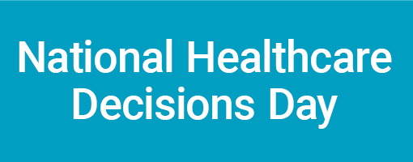

[Date]

Dear [insert name]:

On behalf of the National Healthcare Decisions Day Initiative, I am very excited to be writing to secure your participation in National Healthcare Decisions Day on Friday, April 16, 2010. On this day, all across the country, health care facilities, health care professionals, chaplains, the legal community, and others will be participating in a collective effort to highlight the importance of making advance healthcare decisions and to provide tools for making these decisions. Please find below a description of the rationale and strategy for this initiative as well as a flyer about the event.

As you may know, the Federal Patient Self-Determination Act requires that all Medicare-participating healthcare facilities inquire about and provide information to patients on advance directives. It also requires these facilities to provide community education on advance directives. Unfortunately, despite these requirements and state laws giving patients a choice about their healthcare, it is estimated that only a small minority of people have executed an advance directive. Moreover, fewer than 50% of severely or terminally ill patients have an advance directive in their medical records.

National Healthcare Decisions Day seeks to address the public’s misunderstandings about advance healthcare planning and advance directives, including that:

- A living will and a healthcare power of attorney are the same;
- Advance directives are only used for limiting care;
- A lawyer is needed to draft an advance directive and/or that it is hard to do;
- Severe illness or a catastrophic injury will never happen to them.

In an effort to educate the public and demystify the topic of advance care planning, the National Healthcare Decisions Day Initiative is working to:

- Secure participation of every hospital, nursing home, and assisted living facility in the country as well as a broad array of community organizations focused on healthcare;
- Secure participation by professionals throughout the country, including physicians, nurses, chaplains, and attorneys;
- Create a diversified set of resources to provide clear, concise, and consistent information to the public about healthcare decision-making and advance directives (see NHDD.org); and
- Increase the number of people who have engaged in thoughtful advance care planning.

Achieving these goals depends on participation by a broad and diverse set of organizations. We specifically ask you to:

- Endorse the initiative by filling out the enclosed confirmation form;
- Place National Healthcare Decisions Day on your events calendar for April 16, 2010;
- Use your existing communication resources to announce and publicize the event;
- Urge your membership and affiliate chapters to endorse and publicize the initiative as well as “lead by example” by making sure that they have engaged in their own advance care planning; and
- Consider supporting the initiative with an in-kind or cash contribution.

Please know that you need not change what you are already doing to educate the public about advance healthcare decision-making and advance directives--instead, you are simply encouraged to make a “bigger splash” regarding the topic on April 16, 2010. Please also note that there is no cost to participate; however, donations to defray the administrative costs of maintaining the website and distributing press releases and other information are welcome.

Ultimately, National Healthcare Decisions Day strives to provide much-needed information to the public, reduce the number of tragedies that occur when a patient’s wishes are unknown, and improve the ability of healthcare facilities and providers to offer informed and thoughtful guidance about advance healthcare planning to their patients.

We thank you for joining us in making this initiative a success. If you have any questions, please do not hesitate to contact me directly at ______________ or write: nhdd@IHI.org.

Sincerely,

