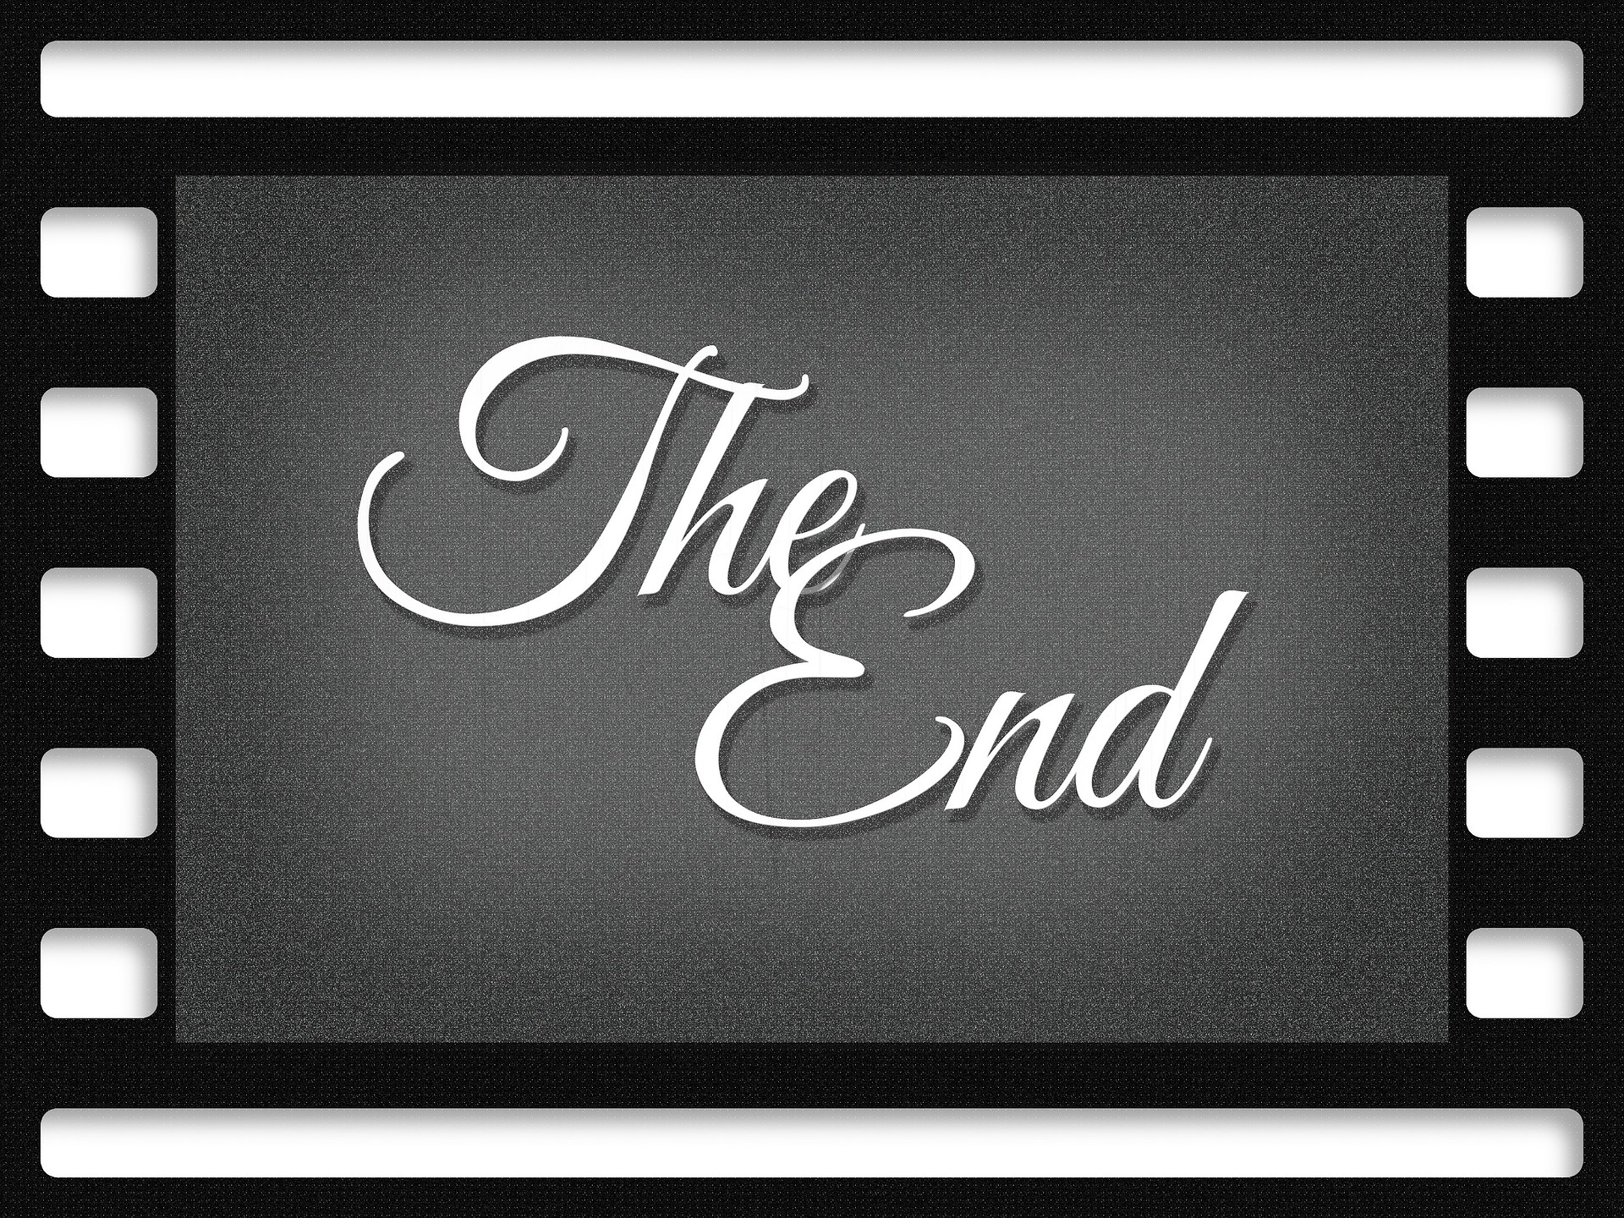

The End: Movies and Mortality
Conversations about End of Life
At the Lafayette Public Library

You are invited to a series of interesting and provocative short videos on end-of-life issues, followed by discussion facilitated by members of the community with related expertise. Each session will begin at 6:30 and end by 7:45.

Free and open to people of all ages. Join us for any or all sessions.

Oct 2: Tom Brokaw, noted journalist, and his daughter, Jennifer, an ER physician, have a heart to heart conversation about what’s important in life and what decisions family members may have to make towards the end of a loved one’s life.

Oct 9: BJ Miller, a hospice physician who lost one arm and both legs in a high voltage accident, asks big questions, such as how we think about death, and how we honor life.

Oct 23: Peg Batten, a bioethicist, tells the story of how and why her husband chose to turn off his ventilator and die, after a bike accident and paralysis.

Nov 6: Funeral Director Caitlin Doughty explores ideas for “green burial,” a process that returns our bodies back to the earth in an eco-friendly and self-aware way.

Nov 20: Lucy Kalanithi shares the journey of her husband, Paul, who wrote “When Breath Becomes Air,” following his diagnosis of terminal cancer at age 36.

