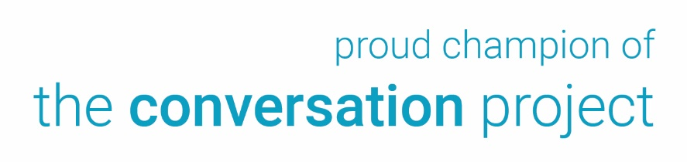
Logo Here]

CONTACT:

[Local Contact]
[Local Organization]
[Email address; phone number]

Discussion on Wishes for Care Through the End of Life Led by [Organization Name]
Hosted at [Location]
[Month, Day, Year]

[Today’s Date] – On [Date of event], more than [Number] of [town/city] residents will gather to discuss the importance of determining and sharing one’s wishes for care through the end of life at [Event Name]. The event, held from [time to time a.m./p.m.] at [location], is hosted by [organization], a proud champion of The Conversation Project.

Since 2012, The Conversation Project (TCP), an initiative of the Institute for Healthcare Improvement (IHI), has been inspiring conversations about care through the end of life within homes and communities, garnering support on national, state and local levels. At the heart of The Conversation Project is its Conversation Starter Guide, a free, downloadable, step-by-step guide developed to help individuals and those who matter most start conversations about care wishes now and through the end of life. TCP also offers free tools for how to choose a health care proxy, how to be a health care proxy, how to talk with a health care team, and guides for caregivers of seriously ill children or people with Alzheimer’s and other forms of dementia.
The Conversation Project’s Conversation Starter Guide was co-created with individuals from diverse backgrounds (race, ethnicity, gender, age, sexual orientation, religions, etc.), including those who have experience with a serious illness or who have gone through the end of life with a friend or family member (adult or child/teen). The Guide has been downloaded more than 550,000 times by individuals from all 50 states and 160+ countries, and its currently available in multiple languages. The Conversation Guide has received support from individuals, healthcare providers, health plans, and employers as a simple and effective tool to normalize the conversation and guide the process.

[More specifics about the event/what participants can expect]

“We are grateful for the support of organizations like [insert organization name] that help us share and spread this important message and work nationwide via intimate community settings,” says Kate DeBartolo, Senior Director of TCP. “We can’t plan for everything. But we can talk about what is most important — in our life, and in our health care — with those who matter most. Having these conversations can strengthen relationships and clarify wishes – something we know nearly all Americans agree is important.”

To register for this event, please contact us at [contact info]. For more information about [organization name], visit [website].

###

