[Your Logo Here]

**Now Offering Free Workshops**

**for Your Community:**

*How to Start the Conversation*

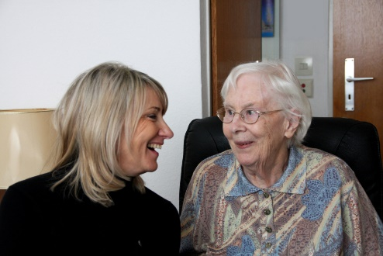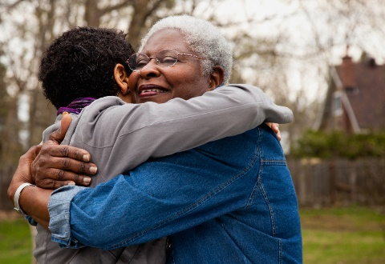

Focus groups of residents, family members, and staff of assisted living facilities indicated a need for more resources regarding advance care planning.*

We can’t plan for everything. But we can talk about what is most important — in our life, and in our health care — with those who matter most.

*Schaffer M, et al. *End of Life Discussion in Assisted Living Facilities.* *J Hosp Palliat Nurs, 14*(1): 13-24.

~

[Organization Name] is the local resource for The Conversation Project, a national initiative dedicated to ensuring that every person’s wishes for care through the end of life are understood and respected.

Contact us to schedule a free workshop facilitated by one of our trained coaches.

[Contact Information]