[Your Logo Here] 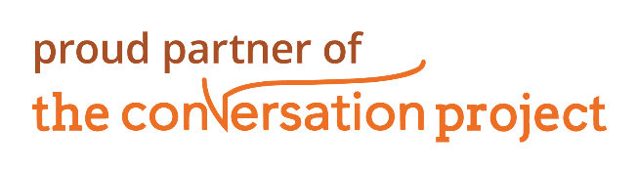

**Now Offering Free Workshops**

**for Your Community:**

*How to Start the Conversation*

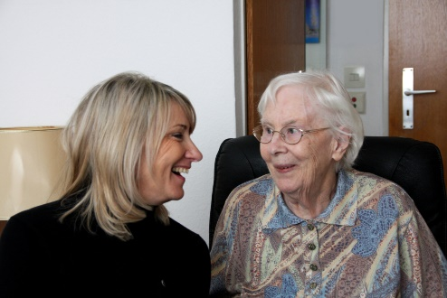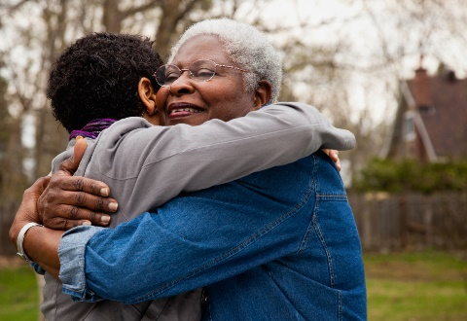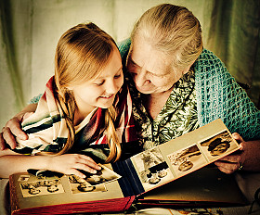

Sources: *TCP National Survey 2018

**Schaffer M, et al. *End of Life Discussion in Assisted Living Facilities.* *J Hosp Palliat Nurs, 14*(1): 13-24.

**92%**

Only

**32%**

have actually done so.*

Focus groups of residents, family members, and staff of assisted living facilities indicated a need for more resources regarding advance care planning.**

~

[Organization Name] is the local resource for The Conversation Project, is a national initiative dedicated to ensuring that every person’s wishes for end-of-life care expressed and respected.

Contact us to schedule a free workshop facilitated by one of our trained coaches.

[Contact Information]

of people think that it is important to talk about their wishes for end-of-life care.