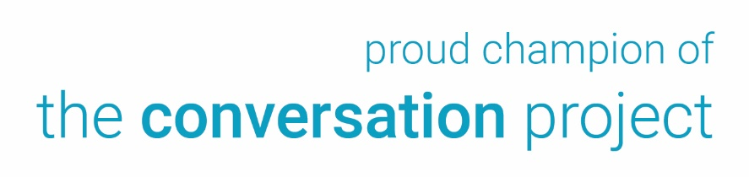
[Your Logo Here]

Become a Conversation Champion
Join us for an important training session.

I want to tell you about a new program coming to [Location] that I am very excited about. The Conversation Project is a national initiative dedicated to ensuring that every person’s wishes for health care through the end of life are understood and respected. You can learn more about it here: https://theconversationproject.org/

Here’s why this topic is important:

92% of Americans believe it is important to have these discussions with their families, yet only 32% have done so. The consequences can be devastating, particularly when family members in the throes of emotional distress must make decisions while guessing what a relative would have wanted.

I hope you will consider becoming a champion for [Organization Name]. As a champion you will promote the benefits of advance care planning to interested groups and individuals. Given your many community connections and the respect others have for you, I think you’d be perfect in this role.

[Organization Name] will host a training session [Date] at [Location]. [Agenda/time]. You will be equipped with all the skills and tools you will need to be a champion.

To register or for more information, contact us at [contact info].

The Conversation Project National Survey, 2018.

